Multimodal Product Intelligence & Content Studio - Gen AI - Gemini-3.6-Flash
AI-Powered Product Content Generator

Project Description:
Multimodal Product Intelligence & Content Studio harnesses Generative AI to turn raw product inputs into consistent, accurate and ready-to-publish content. The platform accepts a product image, a PDF specification sheet and customer reviews, and processes each source through an independent agent: a Visual Intelligence Agent for product imagery, a Document Intelligence Agent for technical specifications, and a Voice of Customer Agent for review sentiment and recurring themes. The extracted signals are merged into a unified product profile from which the Content Strategy Agent produces a product description, key features, FAQs, advertisement copy and social media posts.
Utilizing the Gemini multimodal API (Gemini Flash family, configured through the GEMINI_MODEL environment variable), the studio generates structured JSON content directly from the supplied facts and instructs the model not to invent specifications. A Consistency & Claims Agent then reports the checks performed and highlights customer concerns that the content should address. Built with FastAPI, a vanilla HTML/CSS/JavaScript front end and a local-first processing engine, the system keeps working even when the Gemini API is unavailable: PDF extraction, review analysis, content generation and JSON export all run locally, and Gemini is applied as an optional enhancement. With secure API key management through a .env file, upload size limits and responsible input handling, the studio helps e-commerce teams, marketers and product managers publish trustworthy multi-channel content with confidence.

Scenarios
Scenario 1: A consumer-electronics company uploads a photo of a brown wireless on-ear headphone, its PDF specification sheet and a CSV of customer reviews. The studio extracts the confirmed specifications (for example 40 mm drivers, Bluetooth 5.3 and 100+ hours of playtime), analyses the reviews, and generates a product description, seven key features, FAQs, advertisement copy and social posts, all grounded in the specification sheet.
Scenario 2: Customer reviews show that some buyers expected active noise cancellation, which the product does not have. The Voice of Customer Agent surfaces this recurring concern, and the Consistency & Claims review explicitly advises communicating that the product offers passive isolation only, preventing an unsupported claim from reaching the marketing copy.
Scenario 3: A small seller has only a product name and a few pasted review lines, with no Gemini API key and no specification sheet. The studio still generates a complete content pack through its local fallback workflow, marks the skipped agents clearly, and warns that all claims must be verified against authoritative product information before publishing.

Technical Architecture:
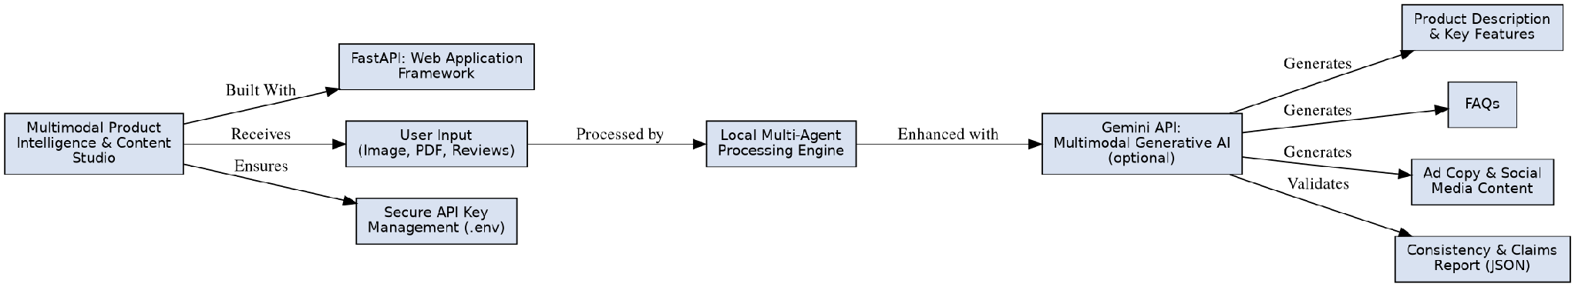

Description:
Multimodal Product Intelligence & Content Studio utilizes a modular three-tier architecture to deliver reliable, AI-driven content generation. The frontend provides a responsive user interface built with HTML, CSS and vanilla JavaScript, where users enter product details and upload an image, a specification PDF and customer reviews. The FastAPI backend validates the uploads, routes each source to its agent in the local processing engine (engine.py), builds a structured prompt and optionally calls the Gemini multimodal API to enhance the output. The result is returned as structured JSON, rendered in the browser and saved to the outputs folder for download. Secure API key management is handled through a .env file loaded at startup, and the application runs locally through Uvicorn.
Note: This project does not use a database. Every generated content pack is stored as a standalone JSON report in the outputs/ folder, so no ER diagram is required.

Pre-requisites:
- FastAPI Framework Knowledge: FastAPI Documentation
- Gemini API Familiarity: Gemini API Documentation
- HTML, CSS, and JavaScript Skills: W3Schools HTML/CSS/JavaScript Tutorials
- Python Programming Proficiency: Python Documentation
- PDF and Image Processing: pypdf Documentation
- Image Handling with Pillow: Pillow Documentation
- Version Control with Git: Git Documentation
- Development Environment Setup: Python venv Guide
- Uvicorn ASGI Server: Uvicorn Documentation

Project Workflow:

Milestone 1: Model Selection and Architecture
- Activity 1.1: Generate a Gemini API key and configure it securely in the project environment.
- Activity 1.2: Research and select the appropriate multimodal generative AI model from the Gemini Flash family.
- Activity 1.3: Define the architecture of the application, detailing interactions between the frontend, FastAPI backend, local multi-agent engine and Gemini integration.
- Activity 1.4: Set up the development environment, installing the necessary libraries and dependencies.

Milestone 2: Core Functionalities Development
- Activity 2.1: Develop the core functionalities: PDF text extraction, image metadata reading, review analysis and structured content generation.
- Activity 2.2: Implement the Gemini integration layer with JSON-mode output, response repair and automatic local fallback.

Milestone 3: Backend and Orchestration Development
- Activity 3.1: Write the main application logic in app.py, establishing the routes, upload validation and JSON report export.
- Activity 3.2: Build the multi-agent orchestrator build_product_pack() in engine.py that coordinates every agent and the optional Gemini enhancement.

Milestone 4: Frontend Development
- Activity 4.1: Design and develop the user interface using HTML, CSS and JavaScript, ensuring a responsive and intuitive layout.
- Activity 4.2: Create dynamic rendering of the agent board and content cards from the API response.

Milestone 5: Deployment and Testing
- Activity 5.1: Prepare the application for local deployment by configuring the virtual environment, dependencies and environment variables.
- Activity 5.2: Launch the application with Uvicorn and verify the health endpoint.
- Activity 5.3: Test the complete workflow end to end in both Gemini-enhanced and local fallback modes.
Milestone 6: Conclusion

Milestone 1: Model Selection and Architecture
In this milestone, we focus on selecting the appropriate generative AI model for our multimodal product content needs. This involves researching the capabilities of the Gemini Flash models, ensuring that the chosen model can understand product images, follow strict JSON output instructions and respond quickly enough for an interactive studio, while the application itself remains reliable even when the API is unavailable.

Activity 1.1: Generate a Gemini API Key
Before the application can use Gemini enhancement, you need a valid Gemini API key. Follow the steps below to create one and connect it securely to the project.
• Step 1 — Open Google AI Studio: Visit https://aistudio.google.com and sign in with your Google account.

• Step 2 — Navigate to API Keys: In the left navigation menu, click "Get API key" to open the API keys page.

• Step 3 — Create a New API Key: Click "Create API key", give it an easy-to-recognize name such as product-studio-key, and select (or create) a Google Cloud project to attach it to.

• Step 4 — Copy the API Key: Copy the generated key immediately and store it in a safe place. Treat it like a password.

• Step 5 — Add the Key to Your Project: Copy the provided .env.example file to .env in the project root and paste the key as shown below. The file also stores the model name:
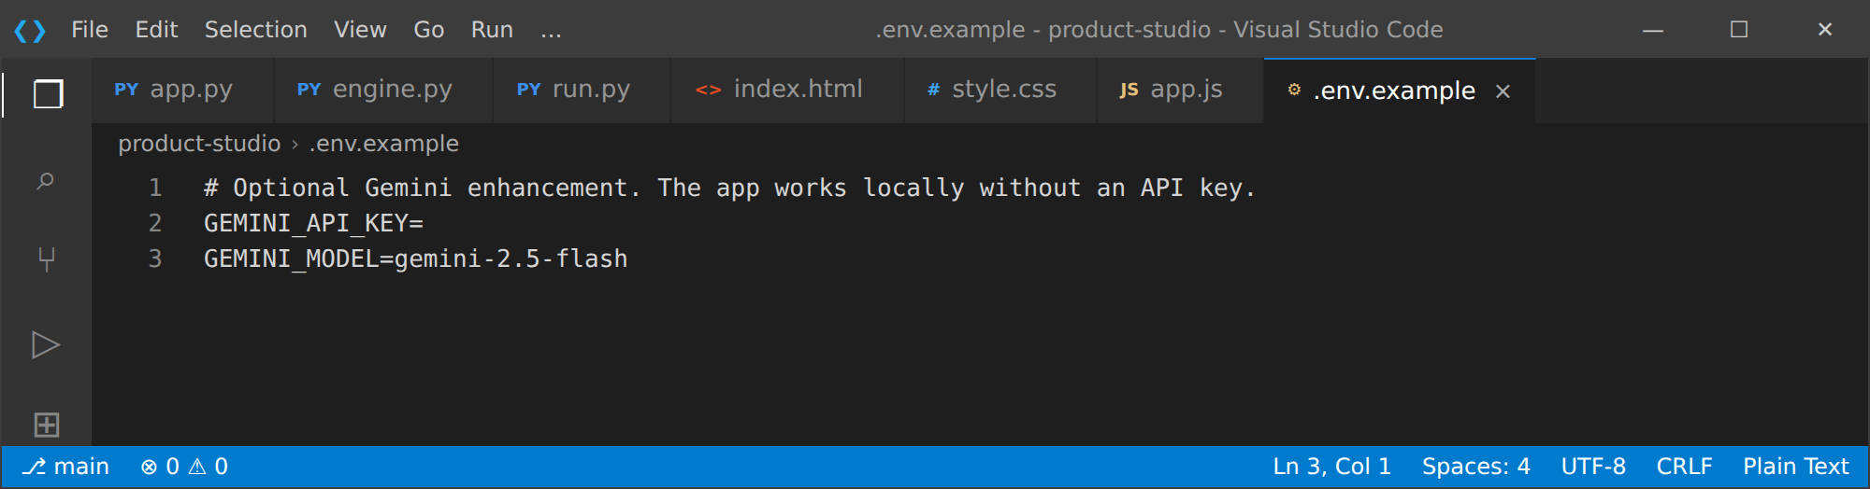
• Step 6 — Verify the Key is Loaded: The launcher run.py loads the .env file with python-dotenv before starting Uvicorn, and engine.py reads the key from the process environment when a Gemini call is made:
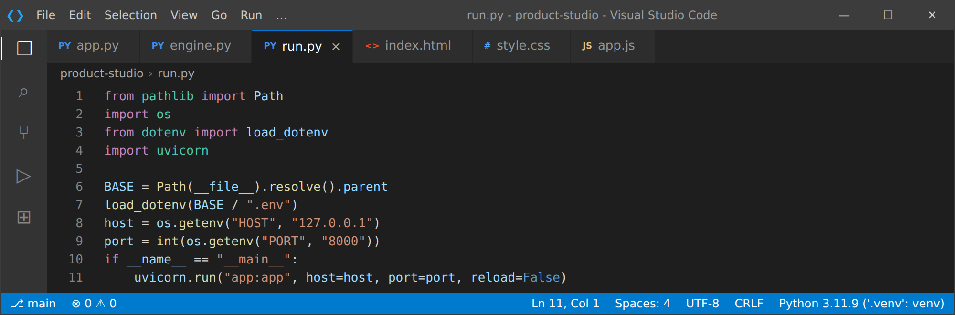
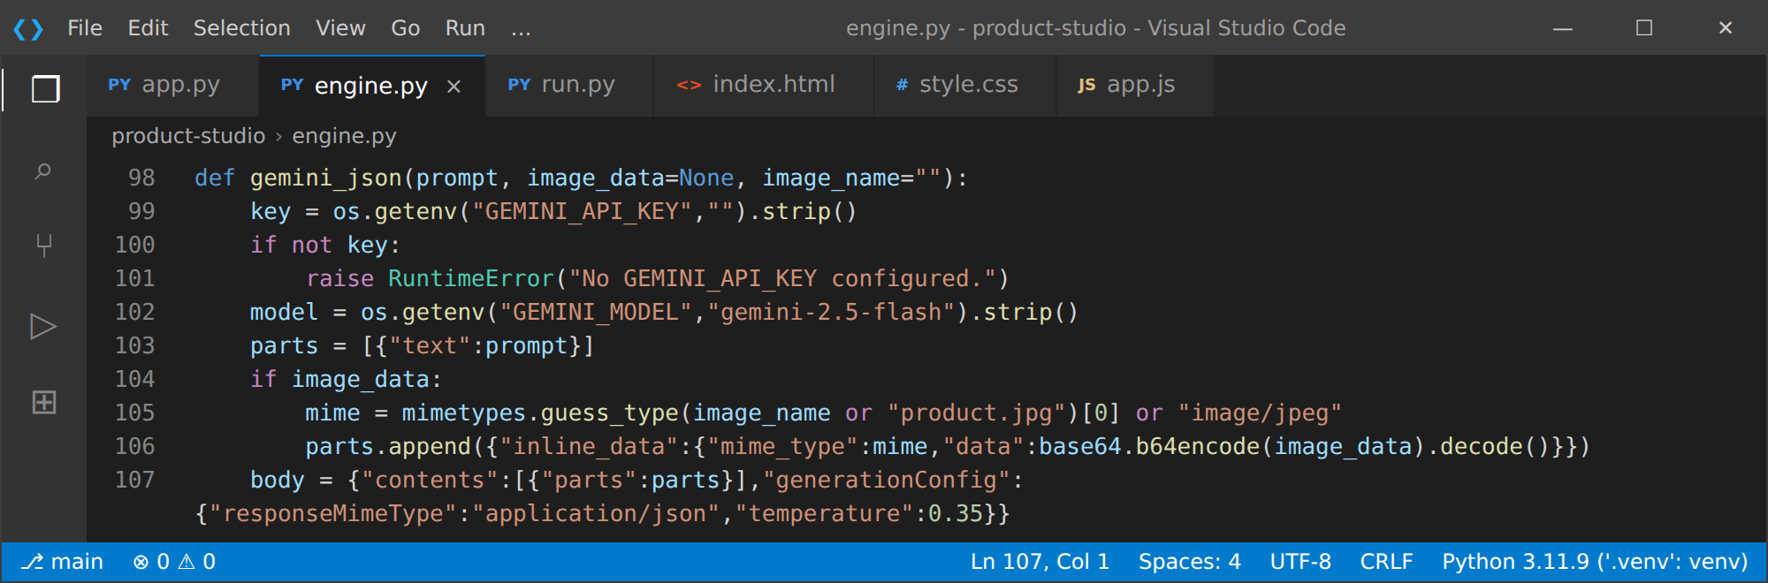
• Important — Never Commit Your API Key: The .gitignore file keeps .env, virtual environments, bytecode and generated JSON reports out of version control:
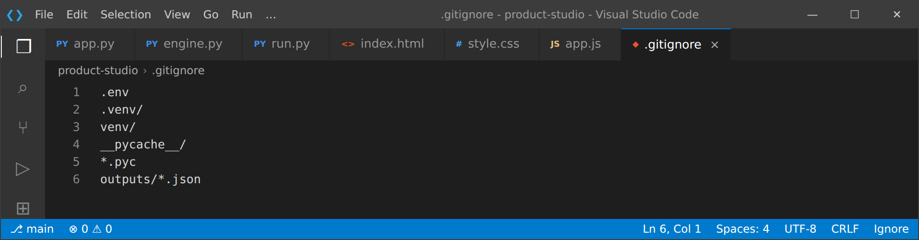
Note: The Gemini key is optional. If GEMINI_API_KEY is empty, the application skips the API call and produces the content pack with its local workflow.

Activity 1.2: Research and Select the Appropriate Generative AI Model
Here are the things that needed to be researched to select the best model for the project:
- Understand the Project Requirements: Review the specific needs of the studio: it must accept an image together with text derived from a PDF and customer reviews, and return six structured outputs (product description, key features, FAQs, advertisement copy, social media content and a consistency review) as valid JSON.
- Explore the Gemini Documentation: Visit the Gemini API documentation to examine the available models, multimodal input support (inline image data), JSON response mode (responseMimeType), context windows, speed and limits.
- Evaluate Model Performance: Compare Flash-class models based on response quality, generation speed, multimodal understanding and adherence to a strict schema without inventing facts.
- Select the Optimal Model: Choose a Gemini Flash model for its balance of multimodal quality and low latency. The model name is read from the GEMINI_MODEL environment variable, so it can be switched to the Gemini 3.6 Flash model ID shown in your Google AI Studio account without any code change. The call uses a temperature of 0.35 for grounded, low-variance output, responseMimeType set to application/json, and a 50-second timeout.
- Design for Reliability: Gemini is treated as an optional enhancement. If the call fails because of quota, timeouts, HTTP errors, invalid JSON or an incomplete schema, the locally generated content is retained and the workflow never stops.

Activity 1.3: Define the Architecture of the Application
- Draft an Architectural Diagram: Create a visual representation of the application architecture, including the frontend (HTML, CSS, JavaScript), the FastAPI backend, the local multi-agent engine and the optional Gemini API integration (see the Technical Architecture diagram).
- Detail Frontend Functionality: Outline how users interact with the application: entering the product name, category, audience and content personality (tone), uploading an image, a specification PDF and a reviews file or pasting review text, and then clicking Build content studio.
- Outline Backend Responsibilities: Specify how the FastAPI backend handles the multipart POST request to /api/generate, validates file sizes (image 12 MB, PDF 15 MB, reviews 5 MB), calls the engine, writes the JSON report and serves it from /api/download/{filename}.
- Describe AI Integration Points: Define how the engine extracts PDF text with pypdf, reads image metadata with Pillow, analyses reviews, builds the local content pack, and then sends one structured prompt (with the image attached) to Gemini, validating that the returned JSON contains all six required keys.
The six cooperating agents shown on the output board are summarized below:
Agent | Responsibility | Status logic (from engine.py)
Input Coordinator | Validates available inputs and routes each source. | Always complete.
Visual Intelligence Agent | Reads the product image (format, width and height; full visual understanding through Gemini). | Complete if an image is supplied, otherwise skipped.
Document Intelligence Agent | Extracts text from the specification PDF (up to 50 pages, 40,000 characters). | Complete if text is extracted; warning if a PDF has no extractable text; skipped if none.
Voice of Customer Agent | Counts review lines, classifies sentiment and finds recurring themes and concerns. | Complete if reviews are supplied, otherwise skipped.
Content Strategy Agent | Creates description, features, FAQs and campaign copy (local or Gemini-enhanced). | Always complete; detail shows which mode was used.
Consistency & Claims Agent | Reports the claim checks and customer concerns to review before publishing. | Always complete.

Activity 1.4: Set Up the Development Environment
- Install Python: Ensure Python 3.10 or newer is installed on your machine (Python 3.11 is used in this project) along with pip for dependency management.
- Create a Virtual Environment: Set up and activate a virtual environment with venv to isolate project dependencies, then install everything listed in requirements.txt:
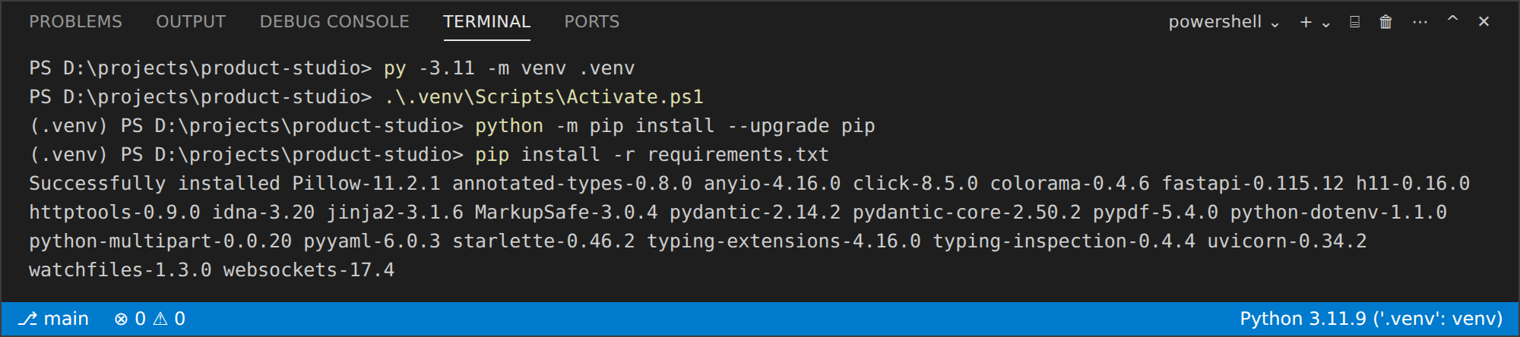
- Review the Dependencies: The pinned packages in requirements.txt are shown below:
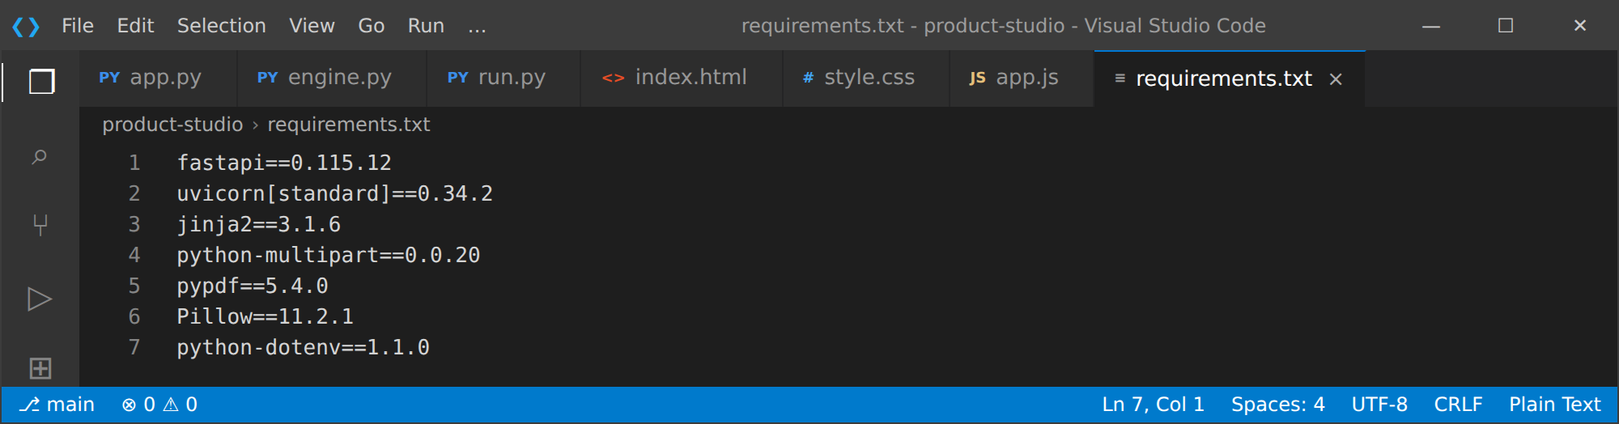
Package | Version | Purpose in the project
fastapi | 0.115.12 | Web framework providing the REST endpoints and automatic API docs.
uvicorn[standard] | 0.34.2 | ASGI server that runs the FastAPI application.
jinja2 | 3.1.6 | Template engine used to serve templates/index.html.
python-multipart | 0.0.20 | Parses multipart form uploads (image, PDF, reviews).
pypdf | 5.4.0 | Extracts text from specification PDFs.
Pillow | 11.2.1 | Reads image format and dimensions.
python-dotenv | 1.1.0 | Loads the .env file (GEMINI_API_KEY, GEMINI_MODEL, HOST, PORT).

- Configure the API Key: Create a .env file from .env.example and add your Gemini API key (see Activity 1.1).
- Set Up the Application Structure: Create the project directory structure with folders for templates and static files (CSS, JS) and the main application files (app.py, engine.py, run.py, requirements.txt):
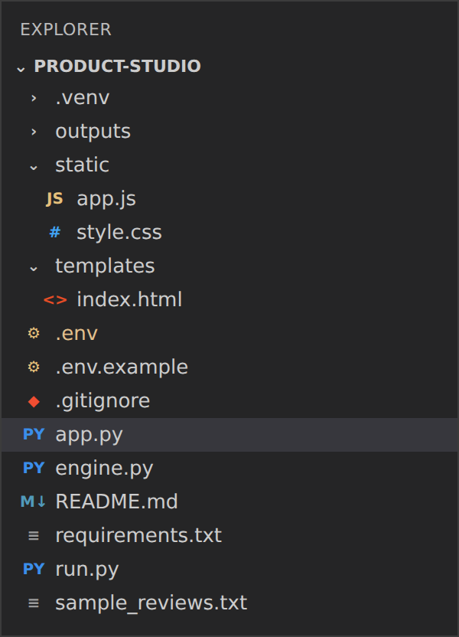
File / Folder | Purpose
app.py | FastAPI application: routes, upload validation and report download.
engine.py | Local multi-agent engine and Gemini integration.
run.py | Launcher that loads .env and starts Uvicorn.
templates/index.html | Single-page studio interface.
static/style.css, static/app.js | Styling and client-side logic.
outputs/ | Generated JSON content packs (created automatically).
sample_reviews.txt | Sample customer reviews for testing.
.env.example, .gitignore, README.md | Configuration template, ignore rules and project guide.

Milestone 2: Core Functionalities Development

Activity 2.1: Develop Core Content Generation Features
Implement the core processing functions in engine.py. Each function belongs to one agent and is designed to work without an external API.
- Document Understanding (pdf_to_text): Opens the uploaded specification sheet with pypdf, extracts text from up to 50 pages, labels each page as [Page N] and caps the result at 40,000 characters. Errors are logged and an empty string is returned so scanned PDFs never crash the workflow.
- Image Understanding (image_details): Uses Pillow to read the image format and pixel dimensions locally. Real visual understanding (type, color, design, material) is obtained when the image is attached to the Gemini request.
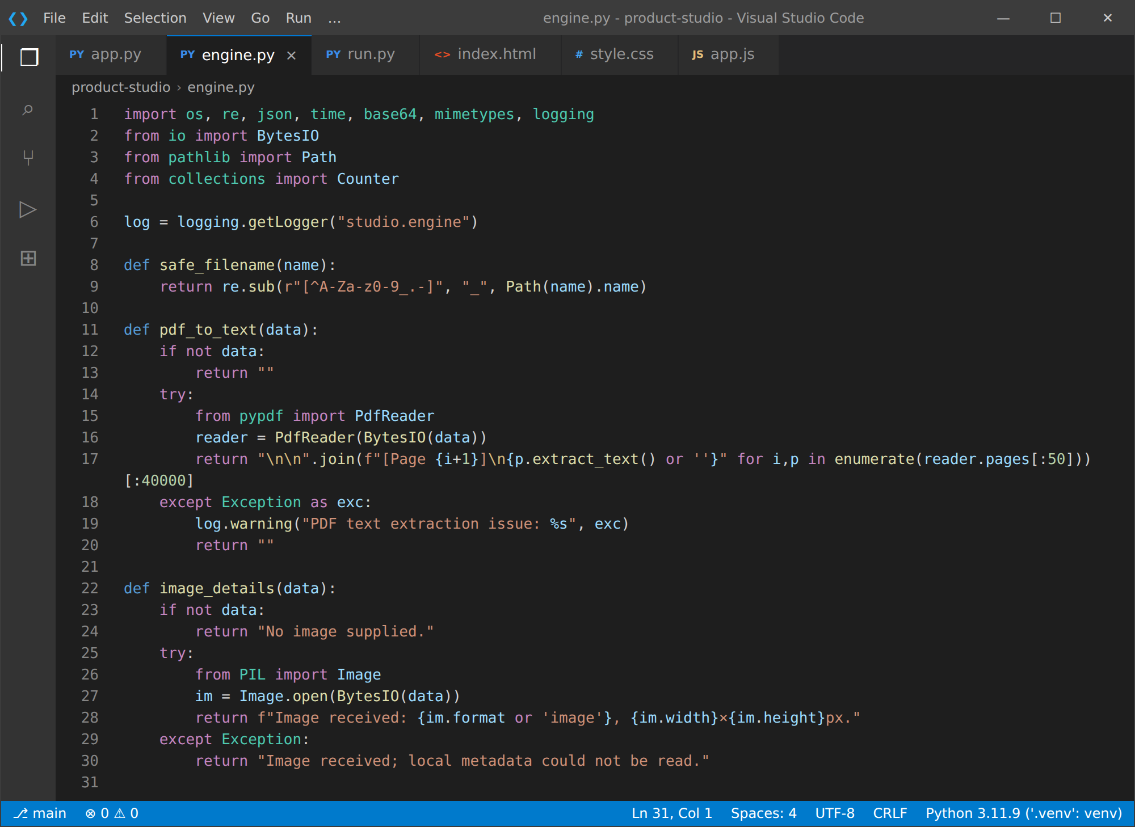
- Voice of Customer (analyse_reviews): Splits the reviews into lines, removes bullet or number prefixes and classifies each line as positive, negative or neutral using the POS and NEG keyword sets. It then returns the review count, the six most frequent positive themes, the recurring concerns, and up to three positive and critical example reviews.
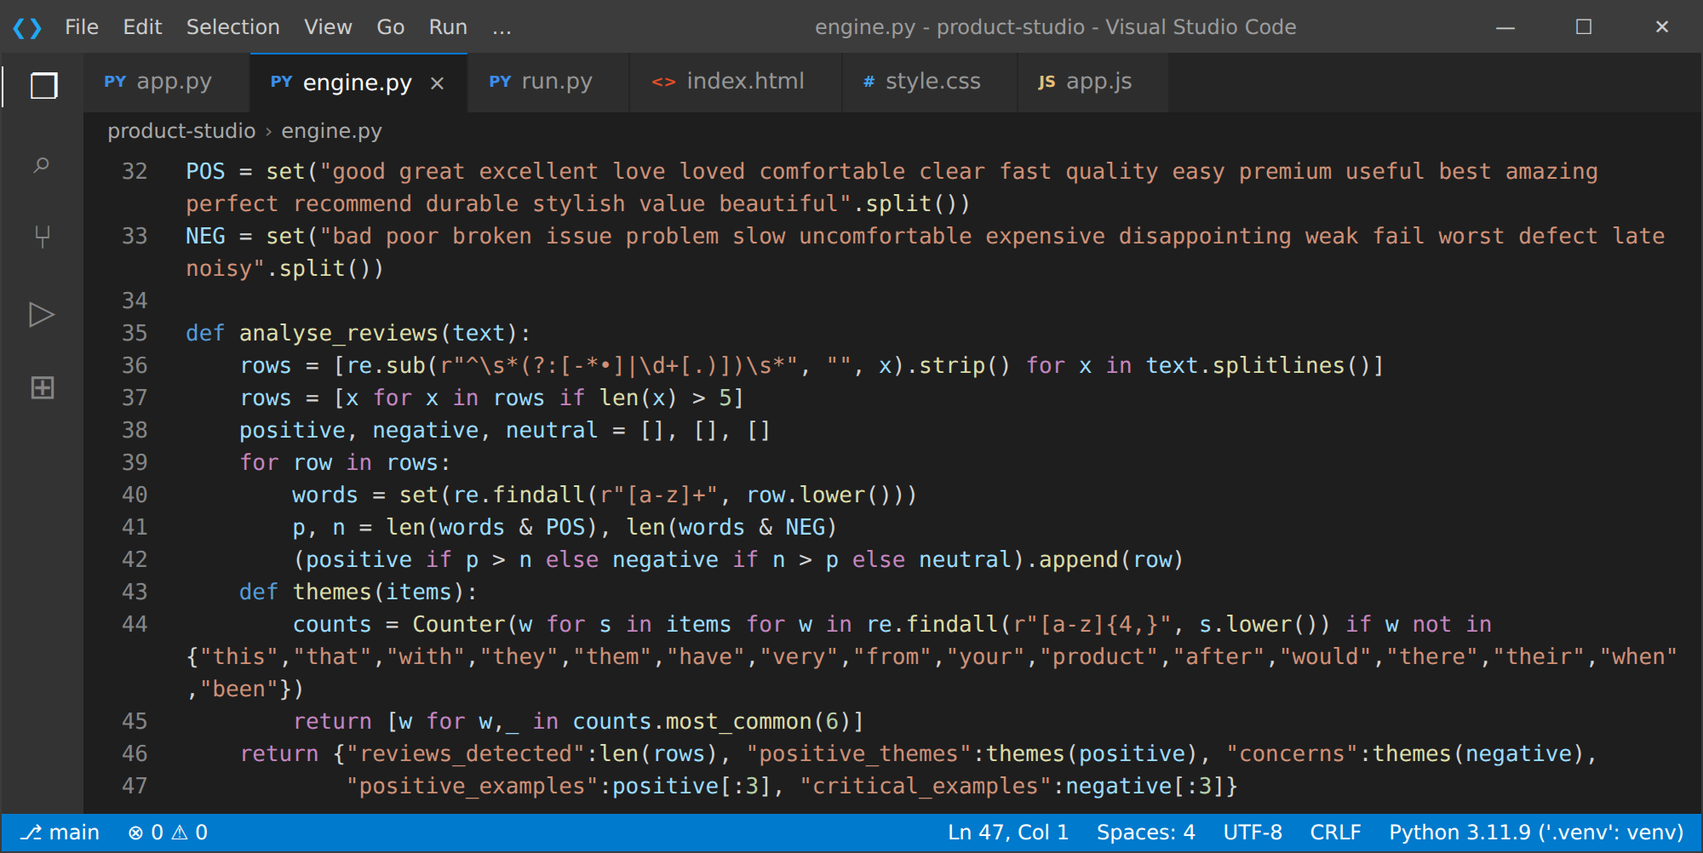
- Product Information Extraction and Content Generation (local_pack): Builds the full content pack locally. Up to six specification lines (12 to 190 characters) become key features; the description, five FAQs, advertisement copy and Instagram, LinkedIn and short captions are assembled from the supplied name, category, audience and review themes. No price, warranty or certification figure is ever added.
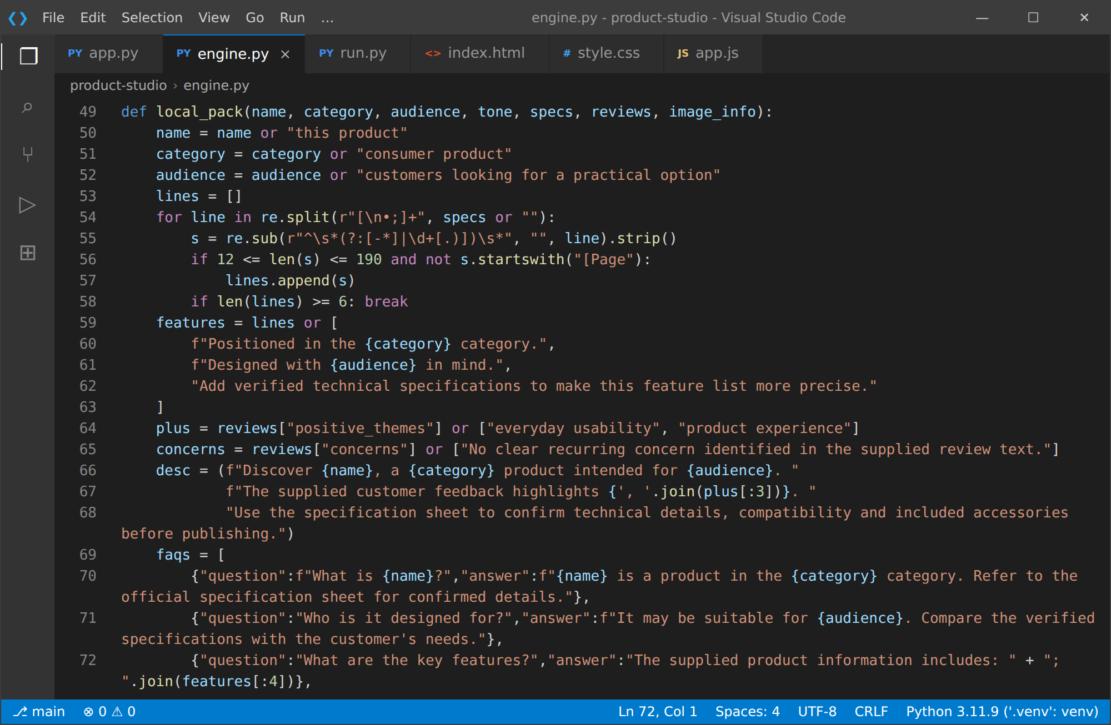
- Content Consistency Checking: local_pack also returns the content_consistency block with the status "Review required before publishing", four standard checks and the customer concerns detected in the reviews.
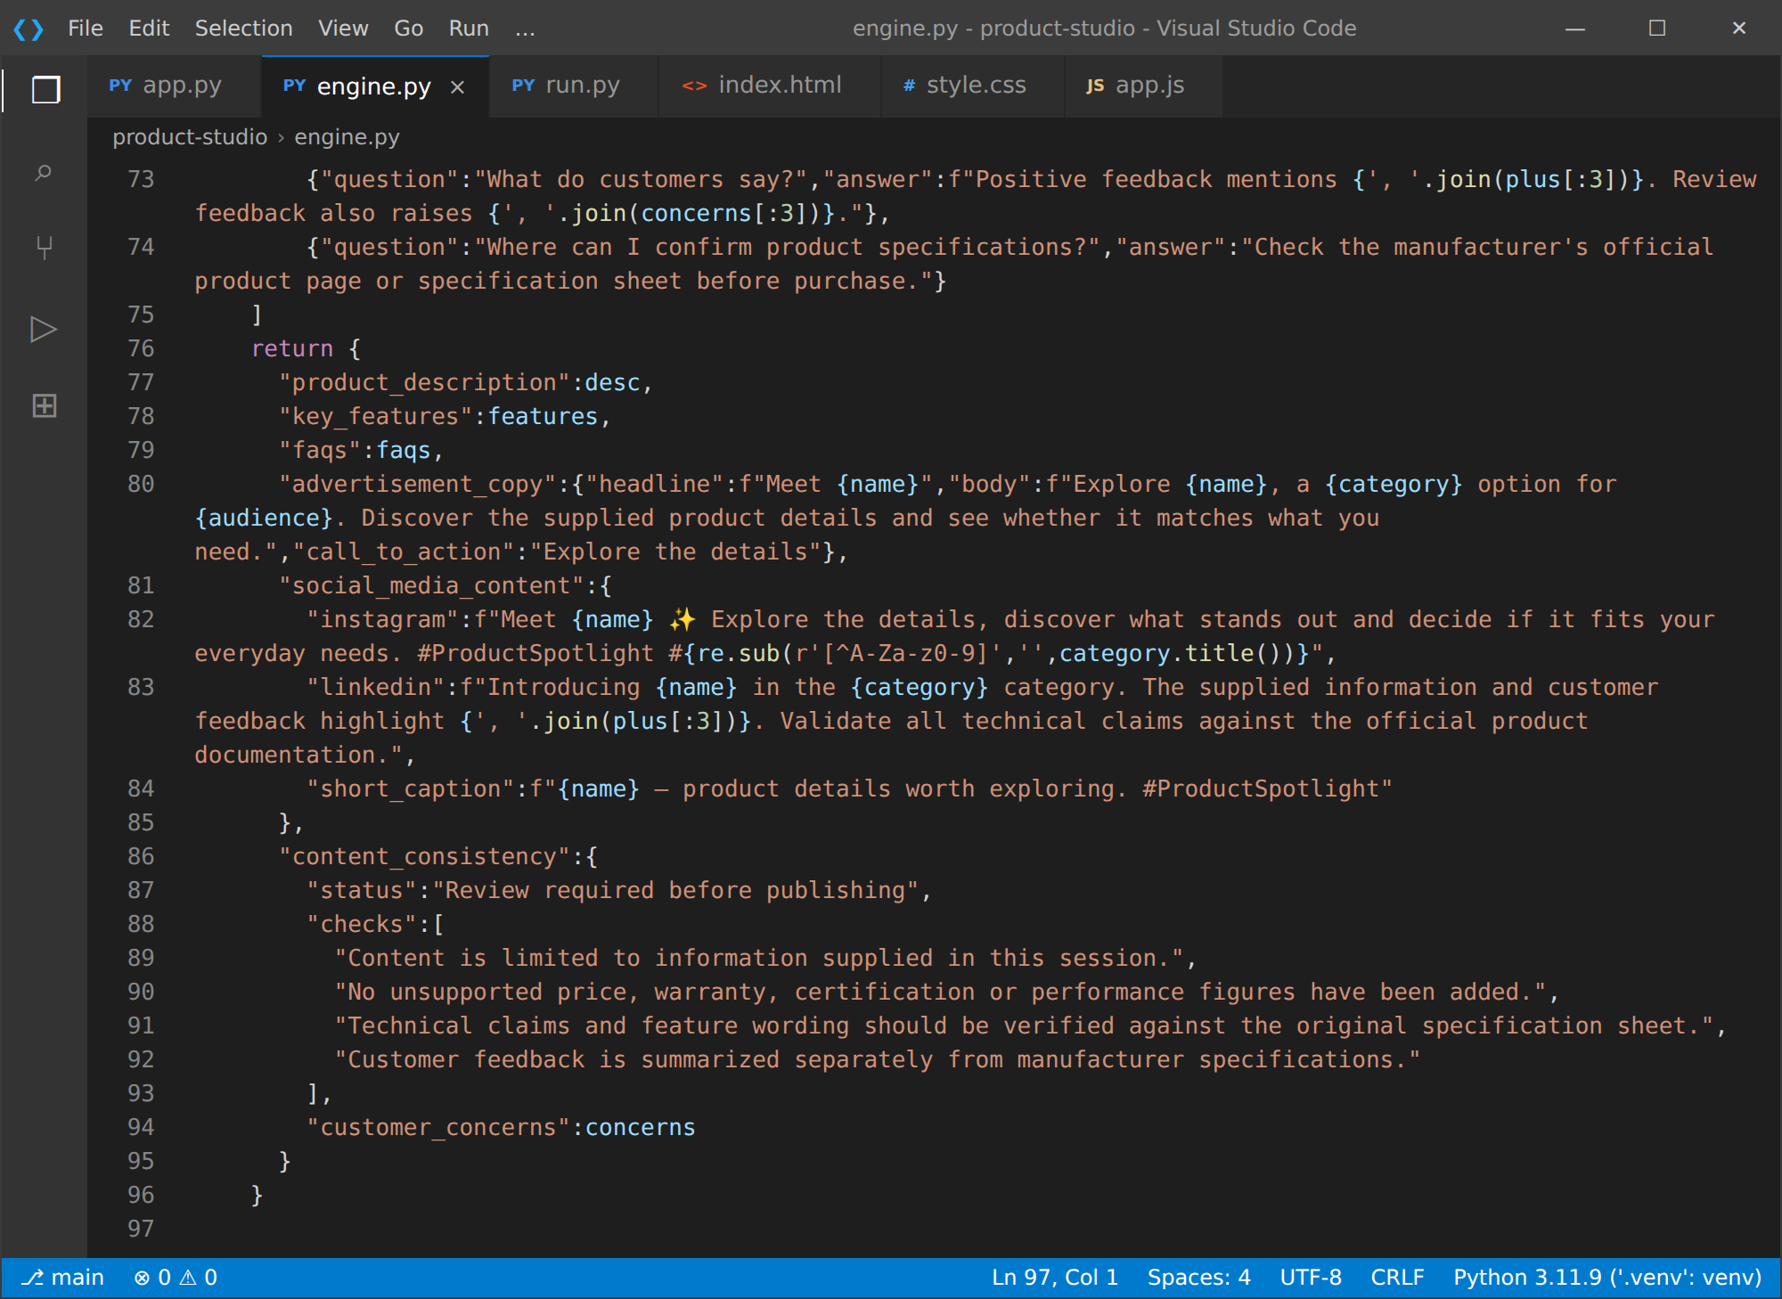

Activity 2.2: Implement the Gemini Integration Layer
Call the Gemini REST API:
- gemini_json() reads GEMINI_API_KEY and GEMINI_MODEL from the environment and raises an error if no key is configured, which triggers the local fallback.
- The prompt and, when supplied, the product image (base64 inline_data with the MIME type guessed from the file name) are sent to the generateContent endpoint with temperature 0.35 and responseMimeType application/json.
Repair and Validate the Response:
- The response text is stripped of markdown code fences and parsed with json.loads(). If direct parsing fails, the function extracts the substring between the first "{" and the last "}" and parses that.
- HTTP errors (for example exhausted quota) are not retried; they raise a RuntimeError containing the status and a short detail so the orchestrator can fall back immediately.
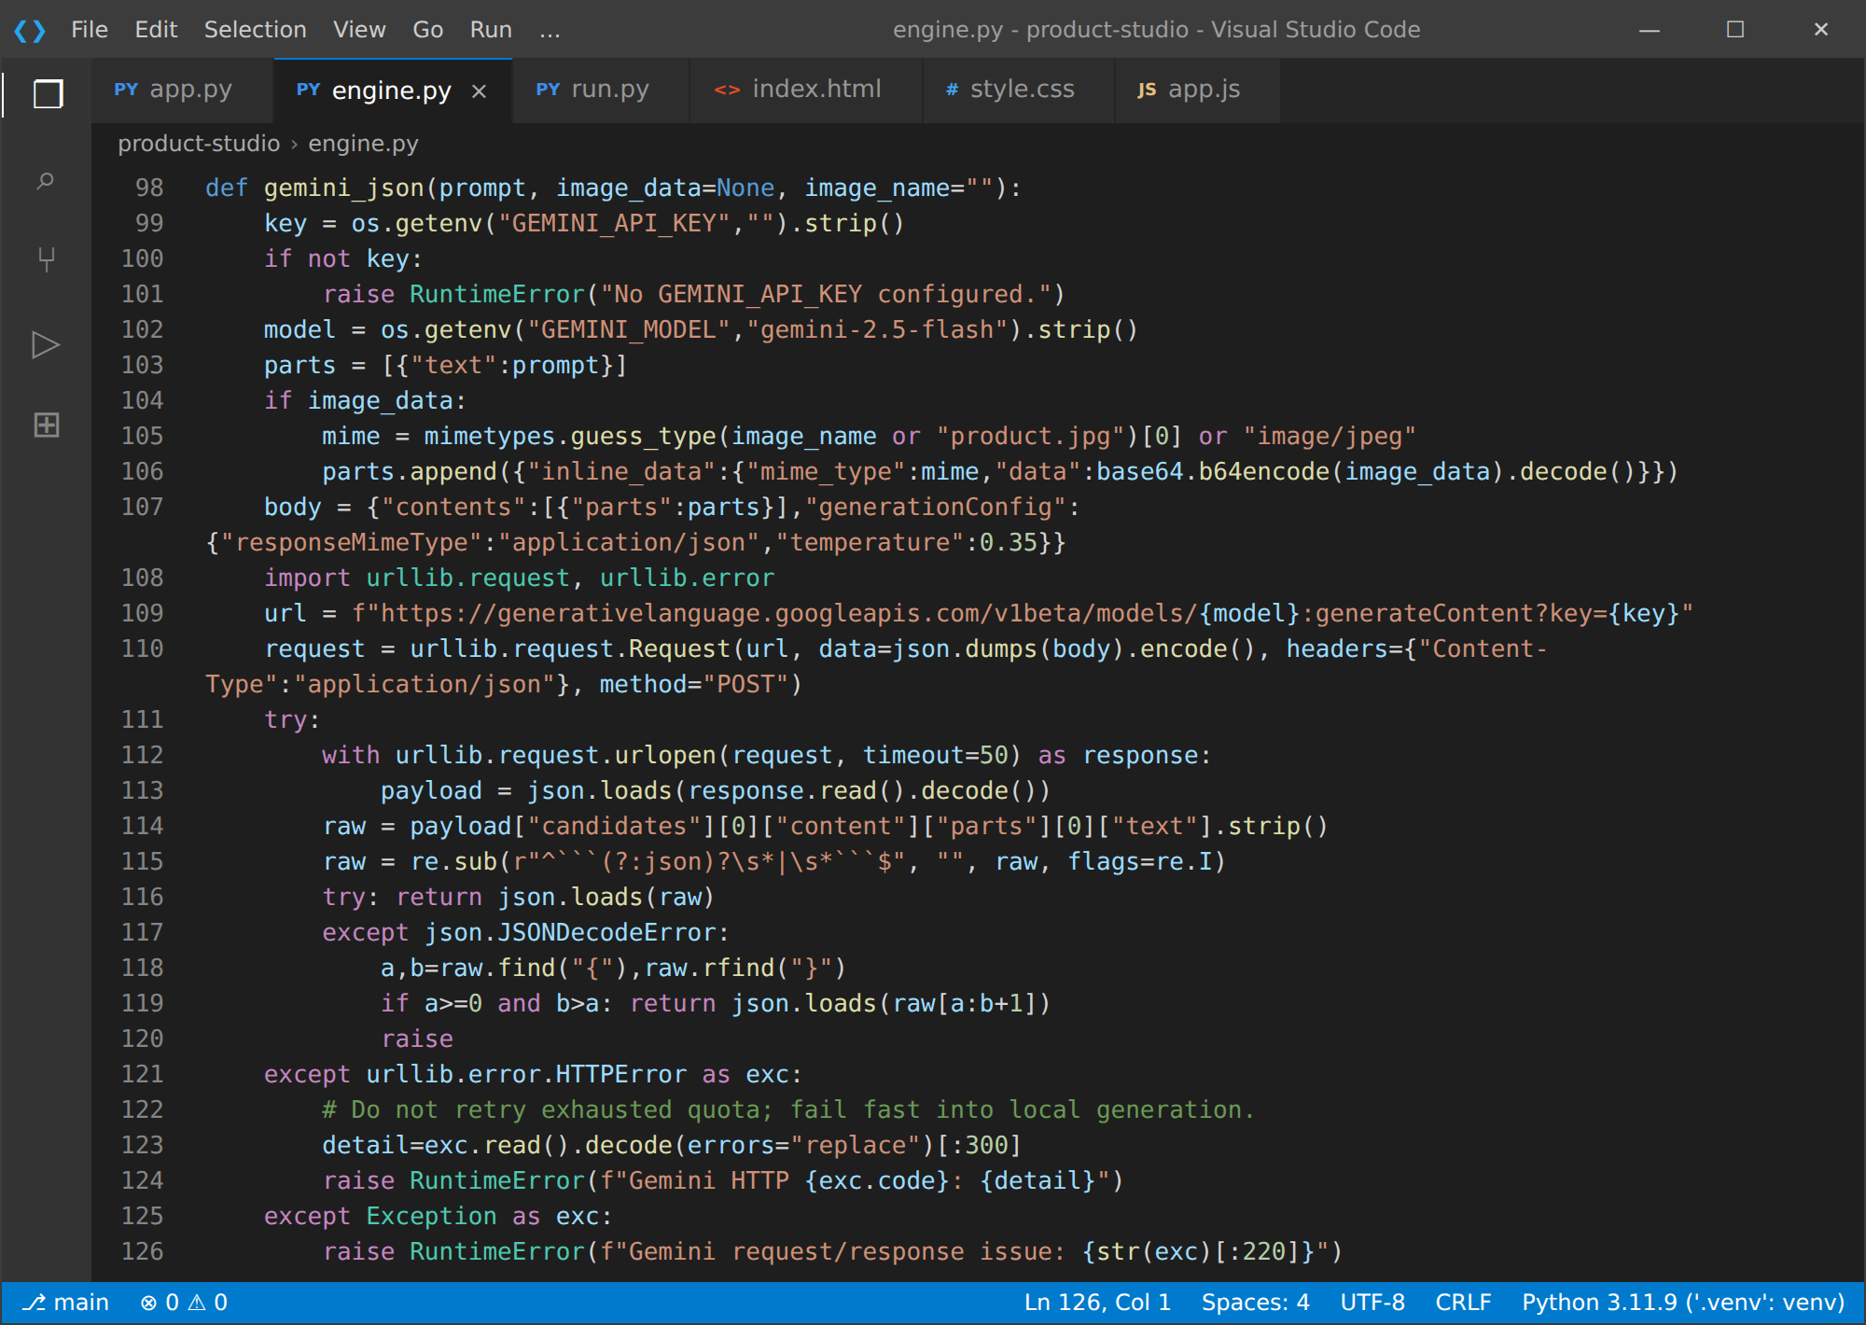

Milestone 3: Backend and Orchestration Development
Milestone 3 focuses on creating and refining the core logic of the application: the FastAPI routes in app.py that receive the uploads, and the build_product_pack() orchestrator in engine.py that coordinates every agent. In this milestone you set up secure upload handling, structured error responses and the JSON report export.

Activity 3.1: Writing the Main Application Logic in app.py
Define the Core Routes in app.py:
- Create the FastAPI application, mount the /static folder, configure Jinja2 templates and make sure the outputs directory exists:
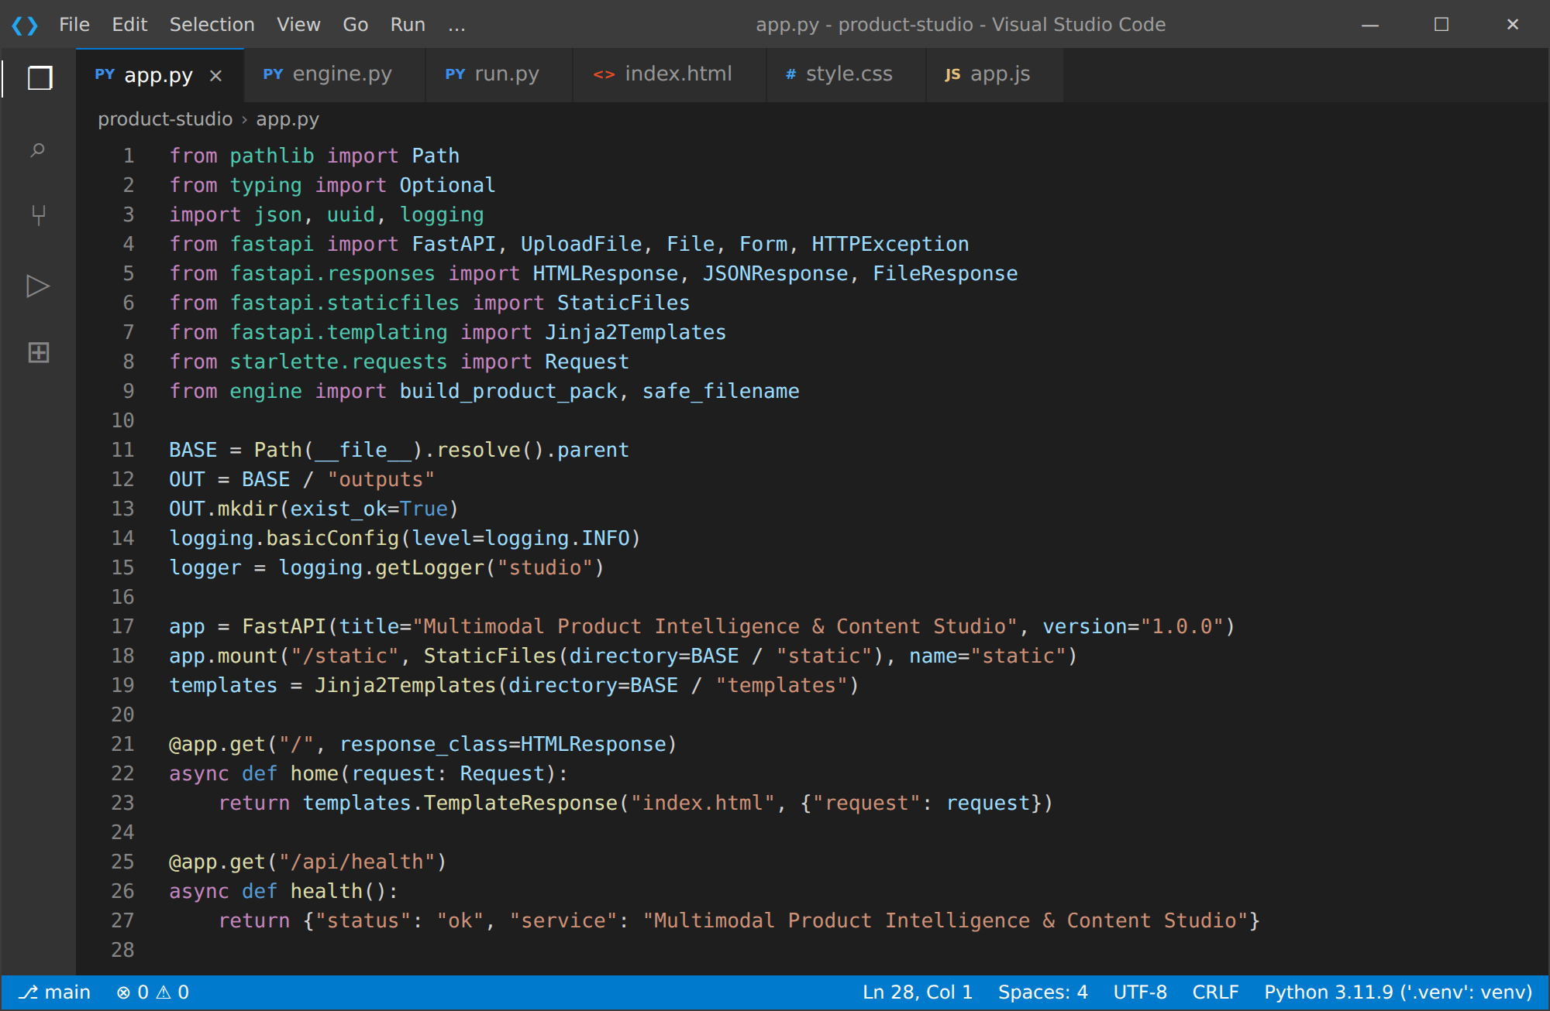
Route | Method | Purpose
/ | GET | Home page: renders templates/index.html.
/api/health | GET | Health check returning status and service name.
/api/generate | POST | Accepts the form fields and uploads, runs the pipeline and returns the content pack as JSON.
/api/download/{filename} | GET | Downloads a saved JSON report.

Process User Input in /api/generate:
- Read product_name, category, audience and tone as form fields, and image, spec_pdf and reviews_file as optional uploads, plus reviews_text for pasted feedback.
- Generate a short request ID with uuid, read each uploaded file and enforce the size limits: 12 MB for the image, 15 MB for the PDF and 5 MB for the reviews file (HTTP 413 otherwise).
- Reject empty submissions with HTTP 400 unless at least one product detail or input file is supplied.
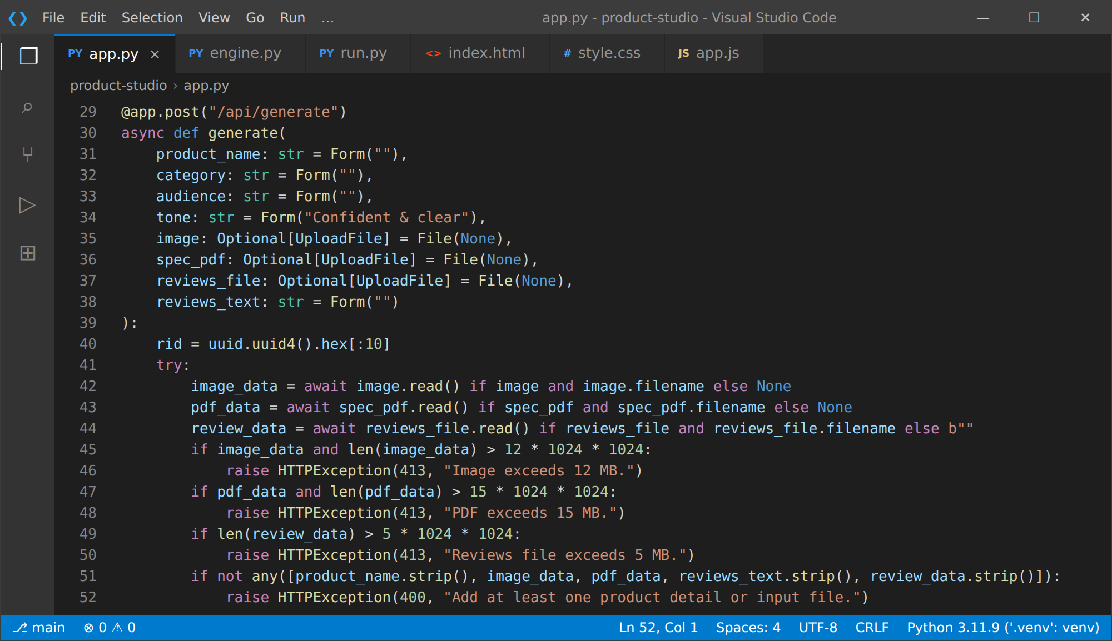
Integrate the Engine and Export the Report:
- Combine pasted text with the decoded reviews file and call build_product_pack(). Add the request ID to the result, save it as outputs/content_pack_<id>.json and return it together with a download_url.
- Unexpected failures are logged with the request ID and returned as a friendly HTTP 500 message. The download route uses safe_filename() to sanitize the file name and prevent path traversal.
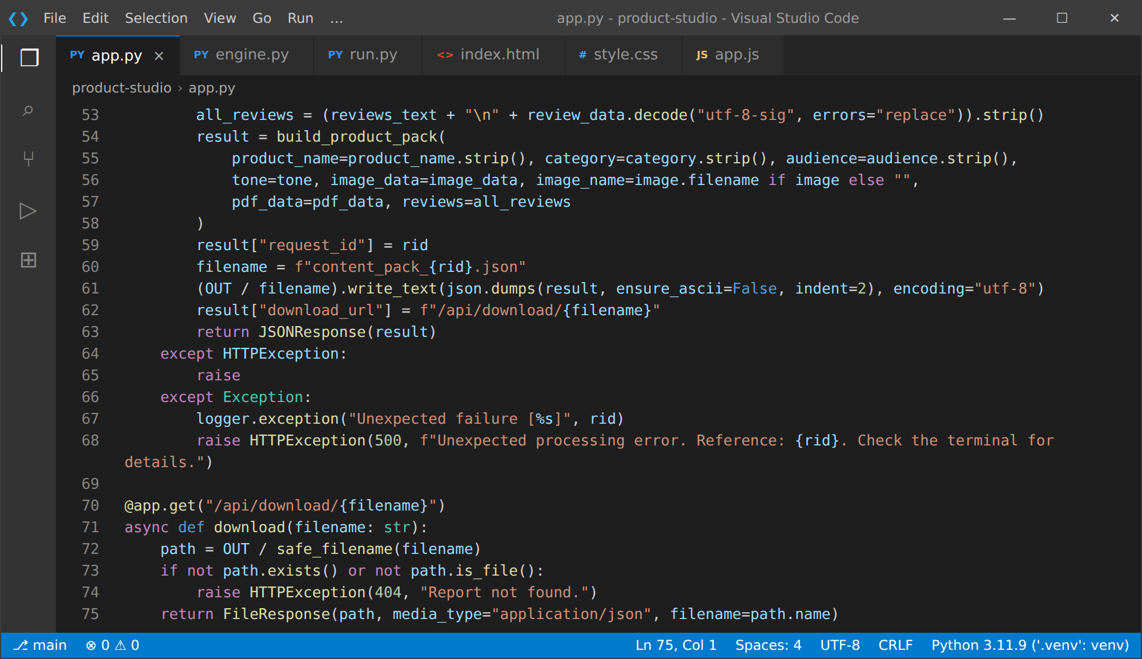

Activity 3.2: Build the Multi-Agent Orchestrator
build_product_pack() is the heart of the system. It executes the agents in order and always returns a valid result:
- Extract the PDF text, read the image details and analyse the reviews, then call local_pack() so a complete local content pack always exists.
- Create the six agent status entries (complete, warning or skipped) with a descriptive detail line each.
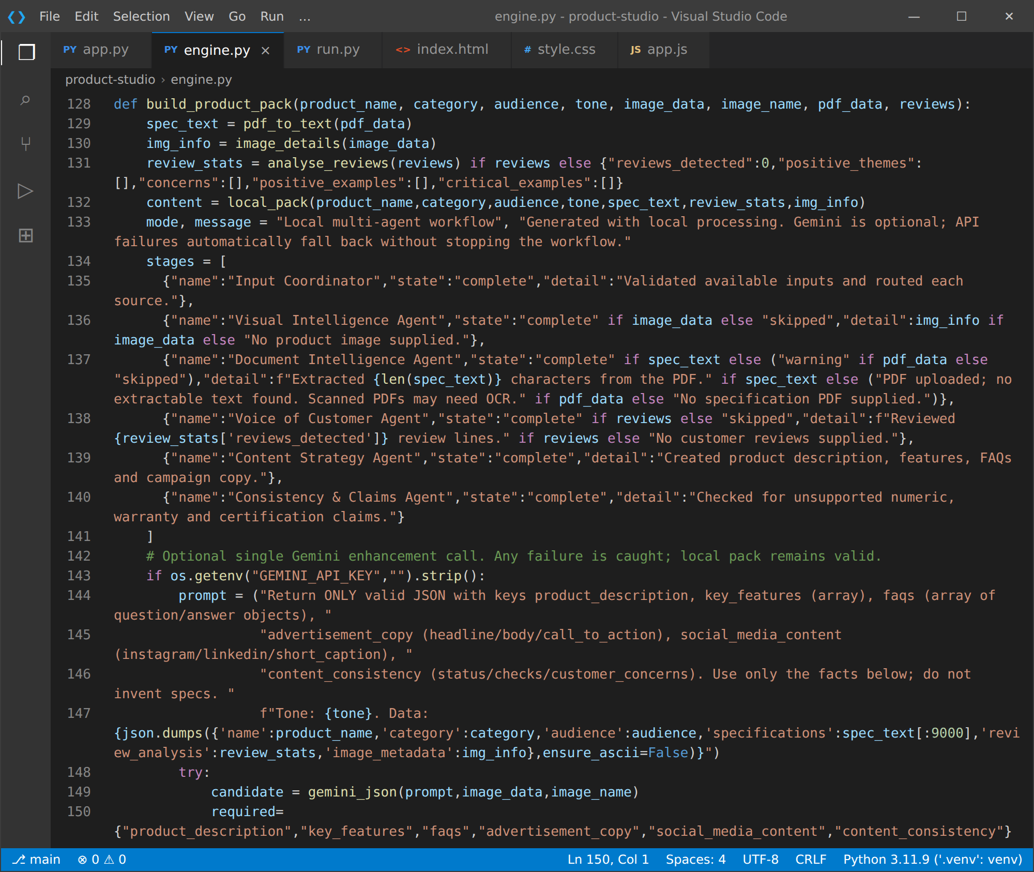
- If GEMINI_API_KEY is configured, build one prompt that demands valid JSON with the six required keys, includes only the supplied facts and the selected tone, and calls gemini_json().
- Accept the Gemini result only if it contains all of product_description, key_features, faqs, advertisement_copy, social_media_content and content_consistency. Otherwise keep the local content and report the reason in generation_message.
- Return the product summary, workflow status, input status, review insights, generation mode and message, content, source notes and the disclaimer.
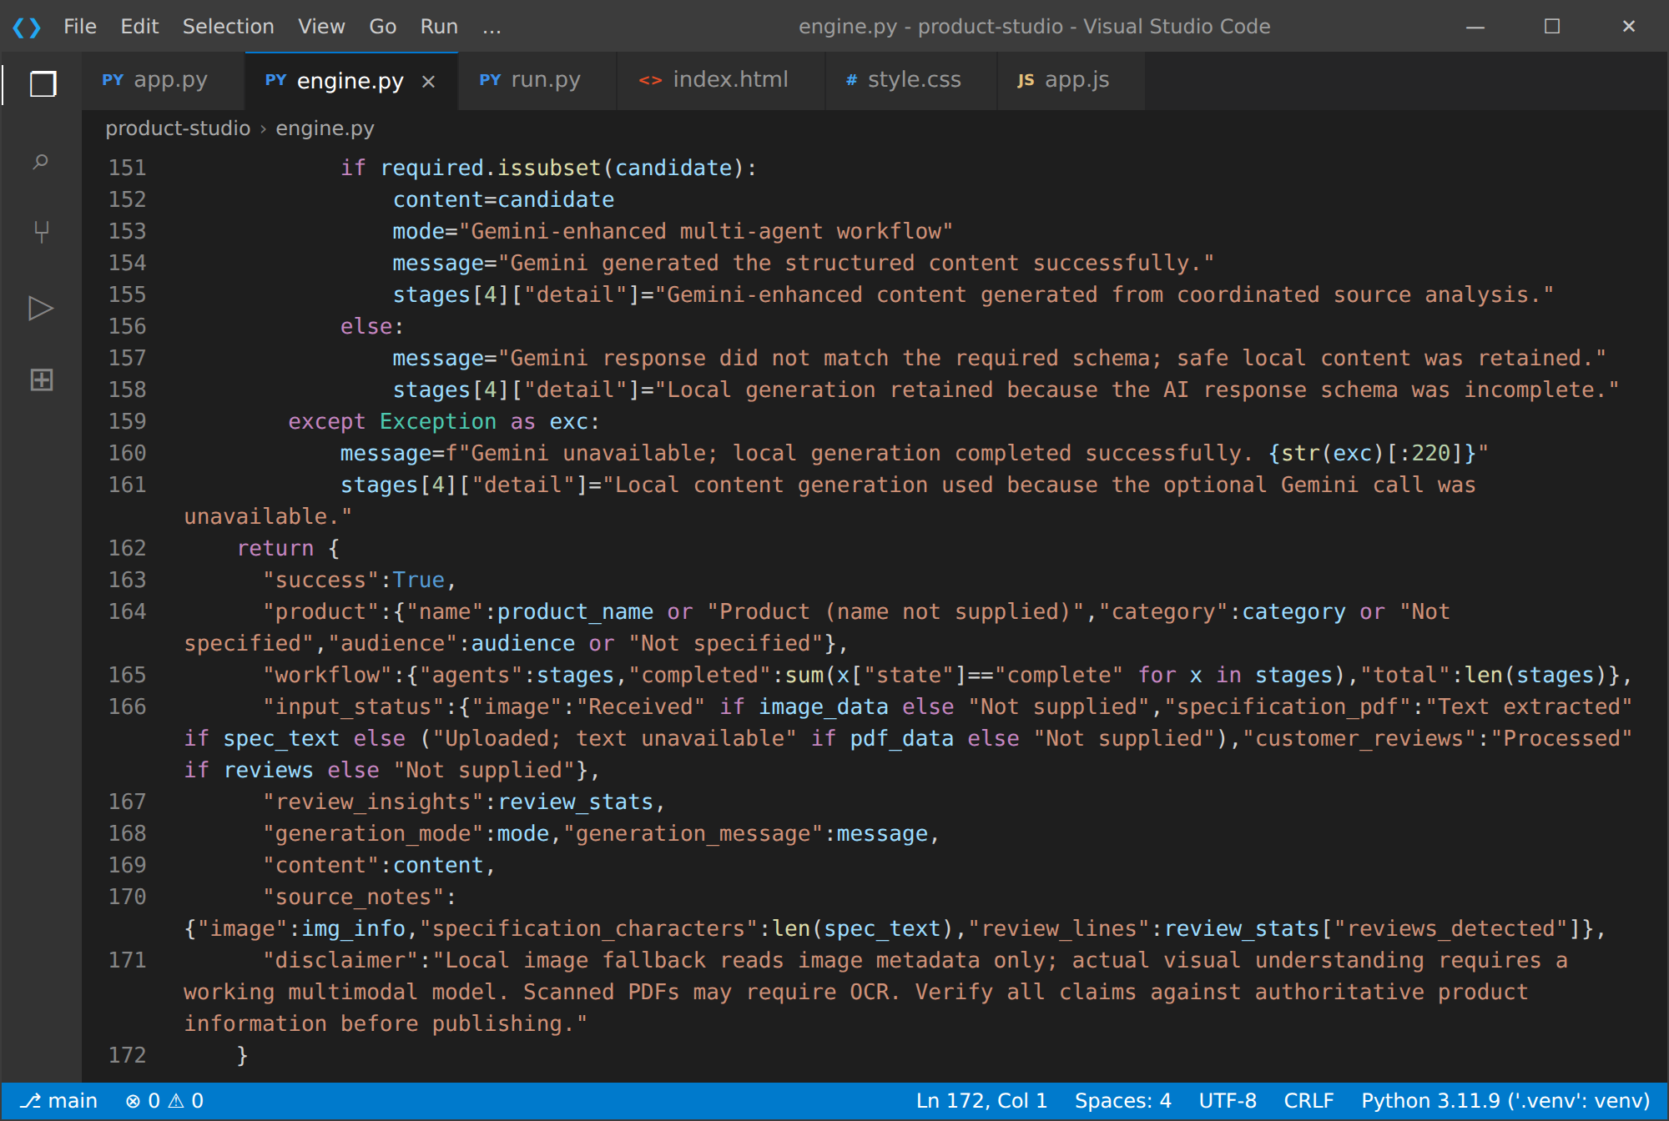

Milestone 4: Frontend Development
Milestone 4 focuses on developing a user-friendly and visually appealing interface for the studio. This involves designing a clean, editorial-style layout with responsive HTML and CSS, and creating dynamic content rendering with vanilla JavaScript to display the agent workflow and the AI-generated content cards.

Activity 4.1: Designing and Developing the User Interface
Set Up the Base HTML Structure:
- Develop templates/index.html as the single-page interface: a navigation bar with the "Form & Function / Product Intelligence Studio" brand, a hero section with a product-signals illustration, the product brief form, three upload cards (image, PDF, reviews), a paste-feedback textarea and the Build content studio button.
- Add the loading, error and results sections, which stay hidden until needed. Typography uses Google Fonts (DM Sans and Manrope).
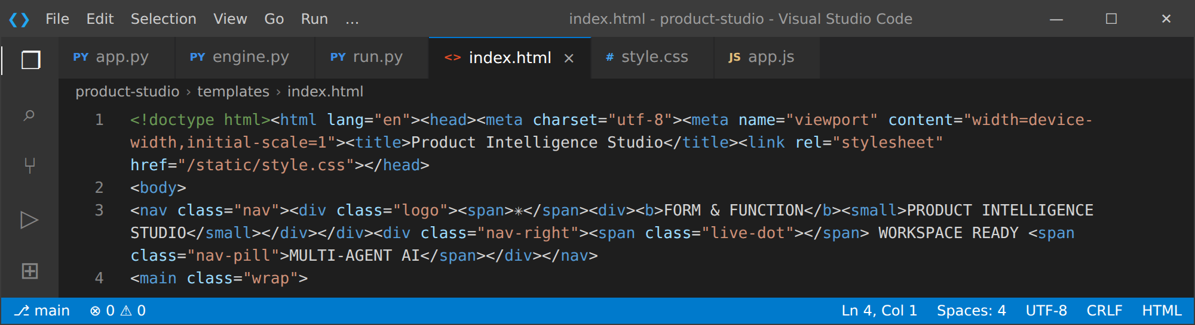
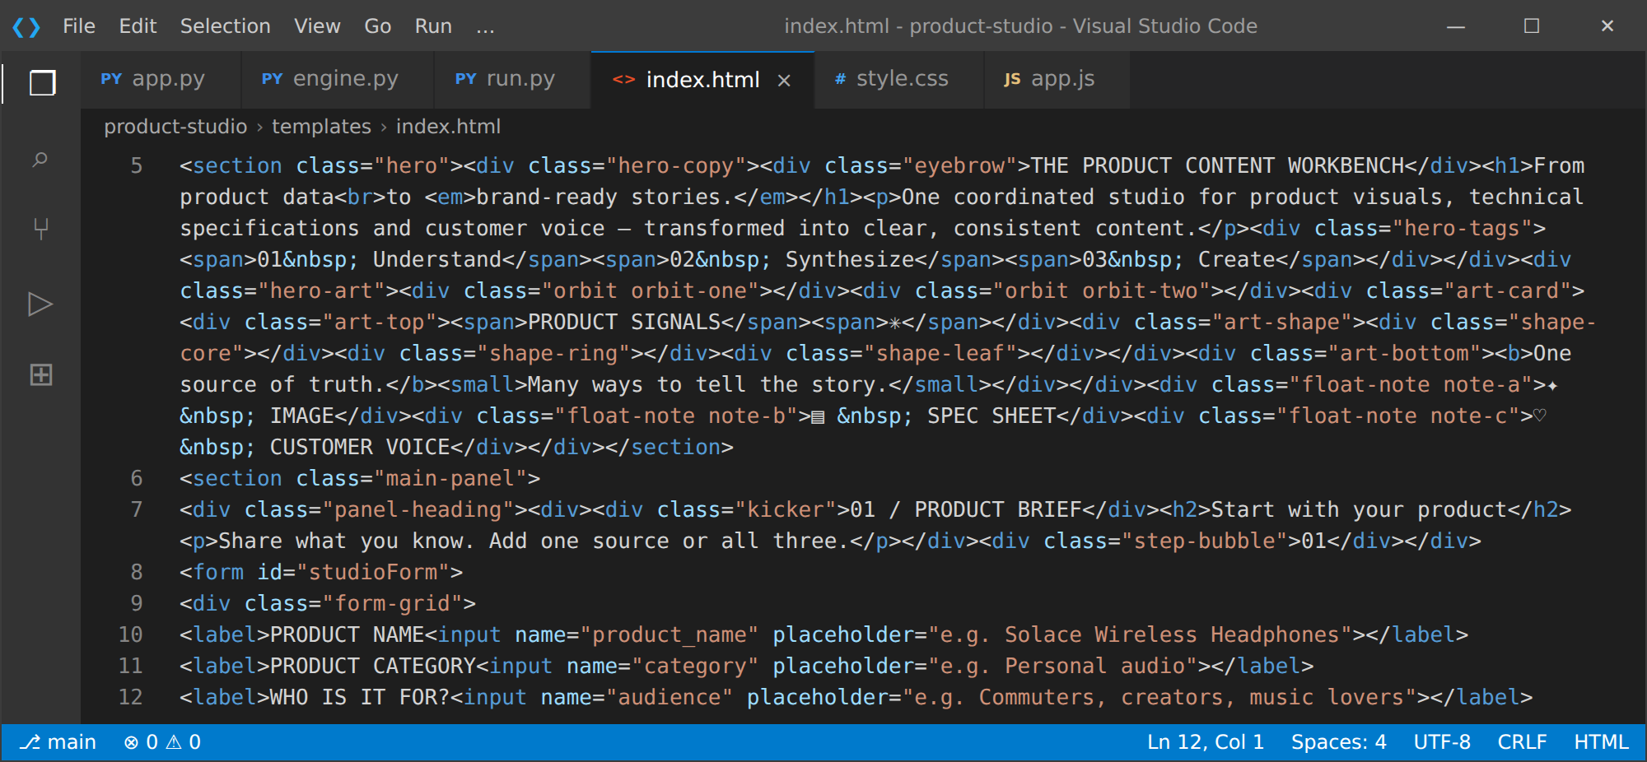
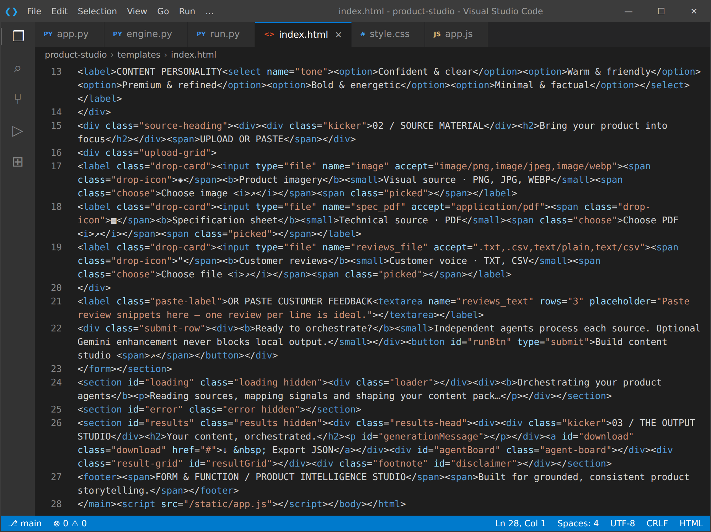
Design a Responsive Layout Using CSS:
- Create static/style.css with design tokens as CSS variables (ink, cream, olive, lime, coral, lavender and gold), a card-based layout and a two-column grid for the results.
- Use flexbox and grid for the hero, form, upload cards and agent board, and a media query at 760 px that collapses the layout to a single column for tablets and mobile screens.
- Style each component: drop cards with dashed borders and hover lift, an animated spinner, status chips for agents (complete, warning, skipped) and output cards with a full-width variant.
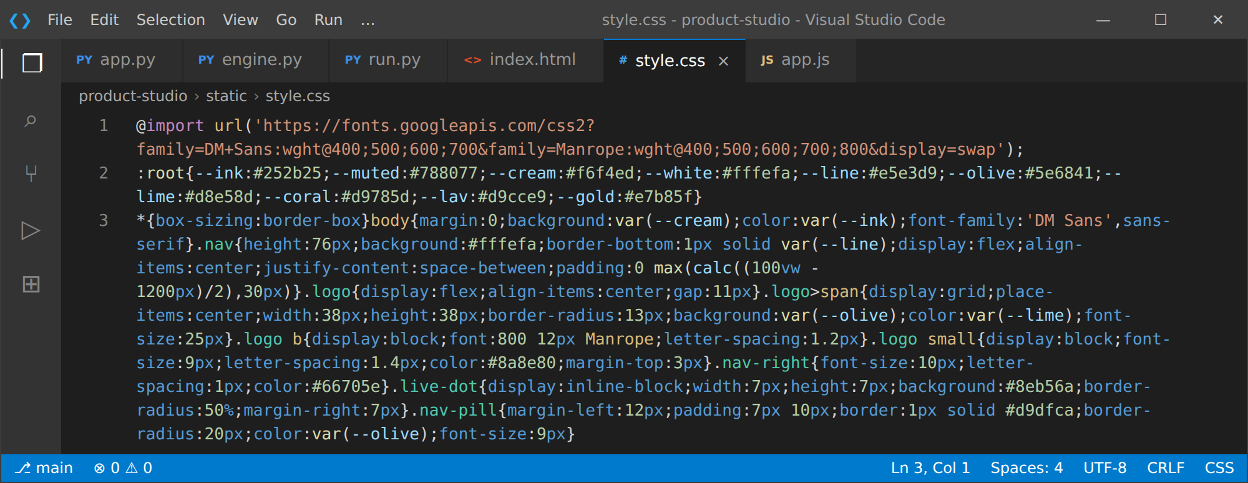
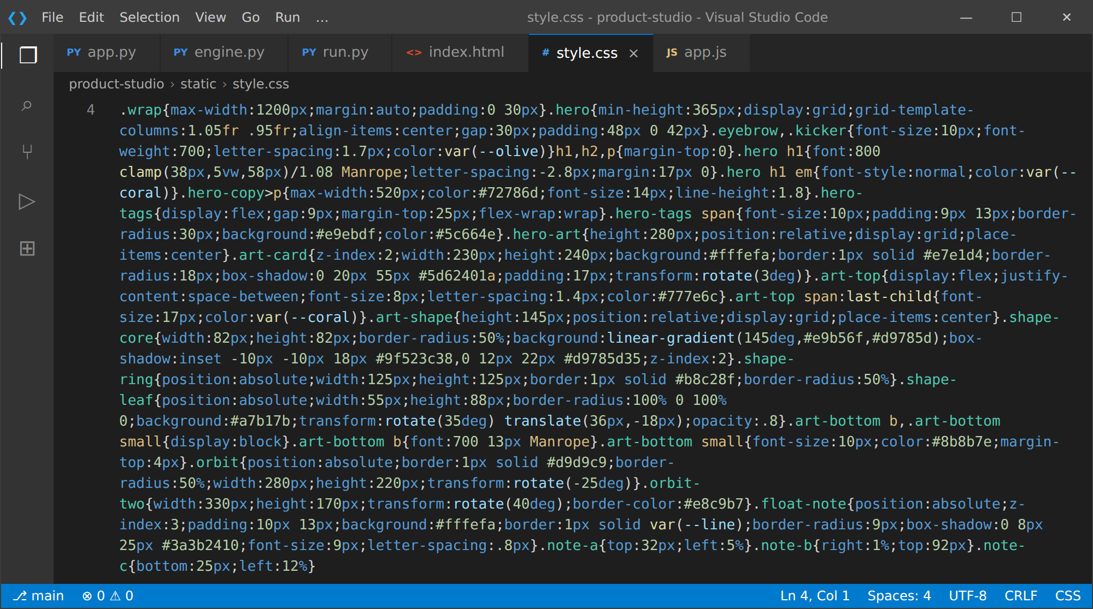
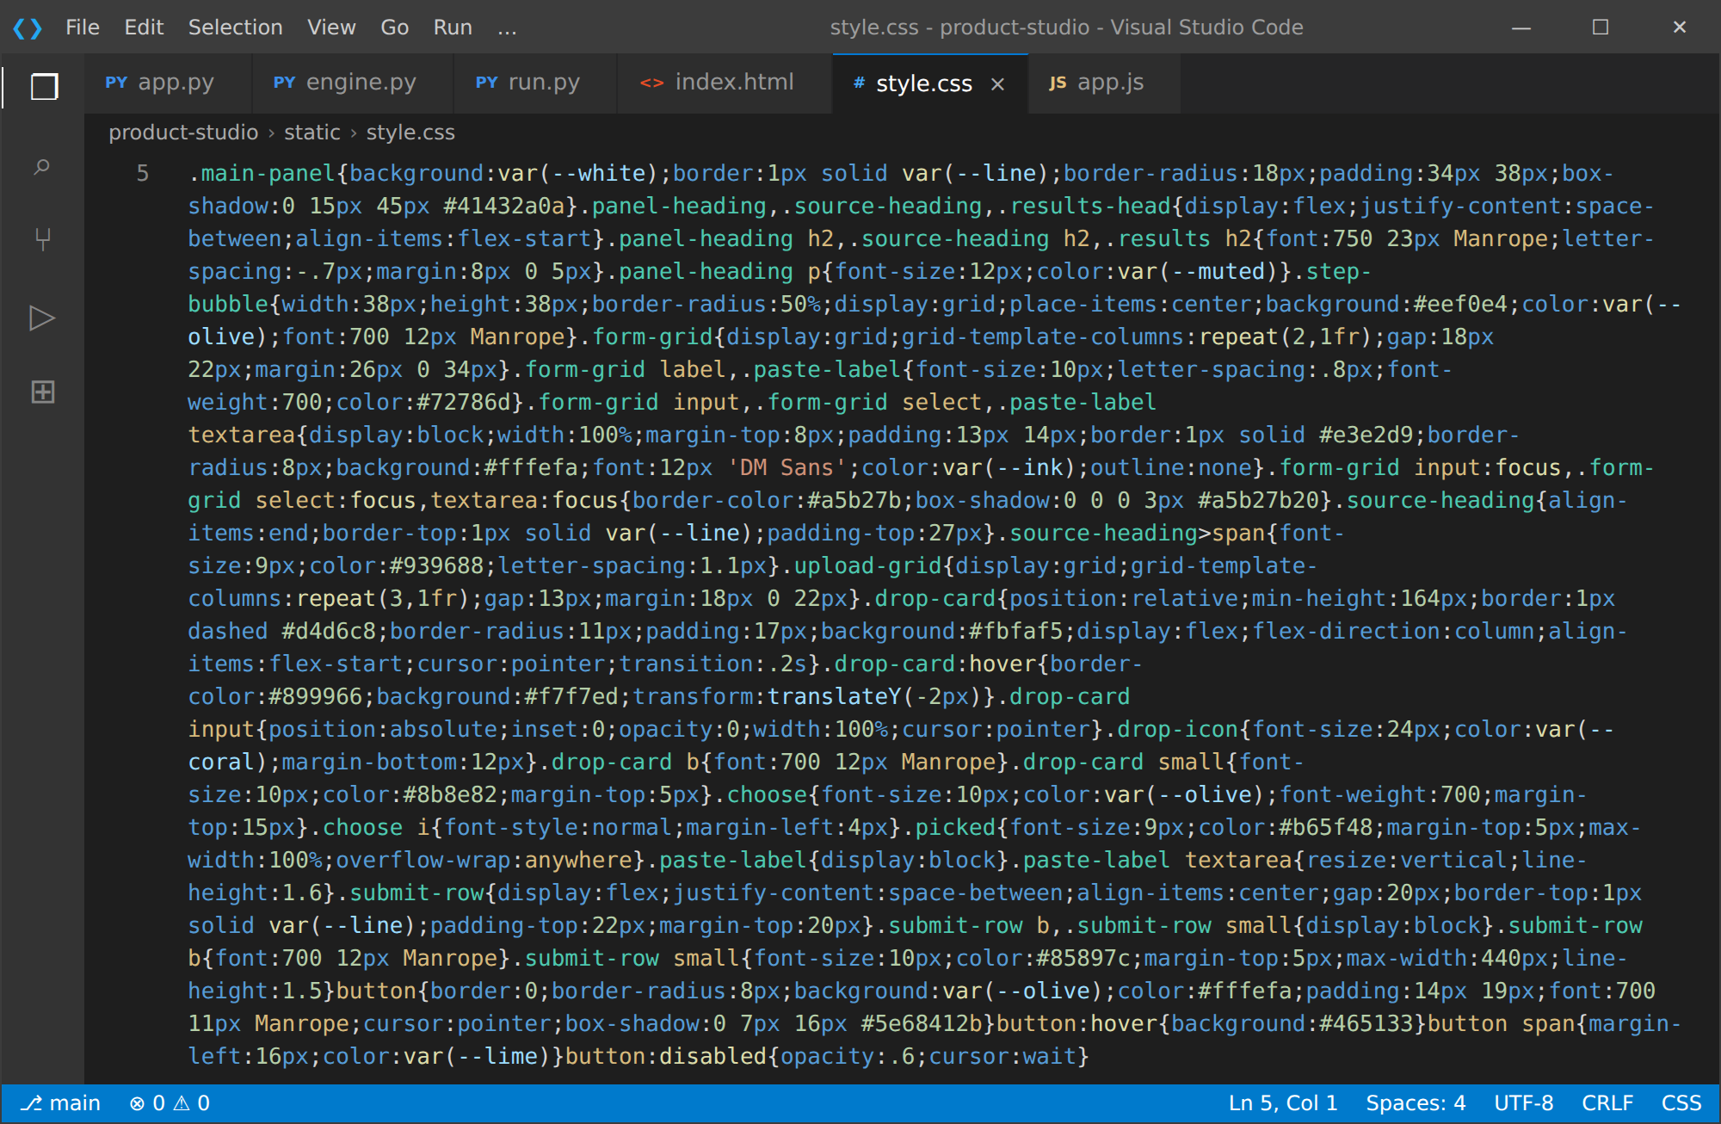
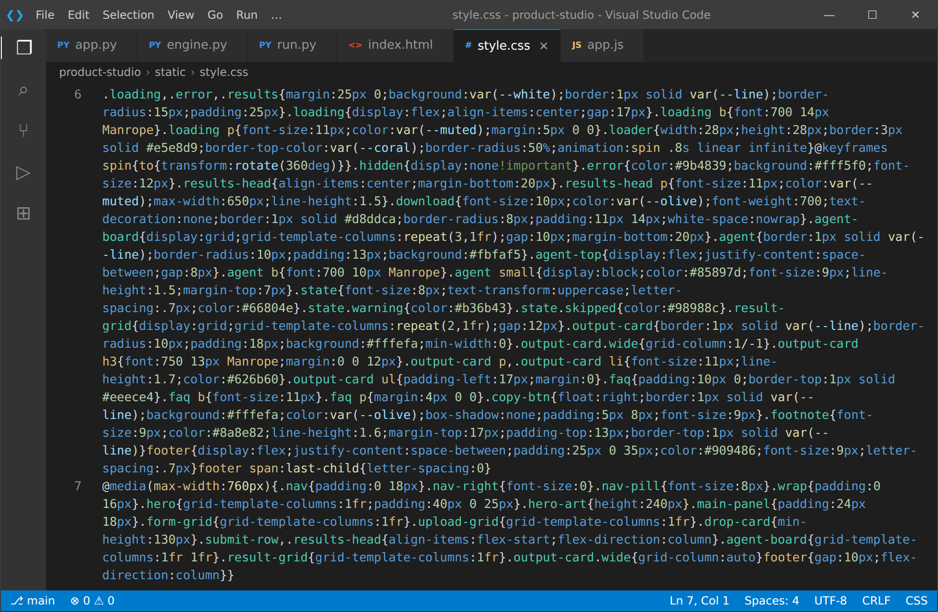

Activity 4.2: Creating Dynamic Content Rendering with JavaScript
Handle Form Submission Asynchronously:
- Attach a submit listener to the studio form that prevents the default submission, hides previous results or errors, shows the loading panel, disables the submit button and sends the form data (including files) with fetch() to /api/generate.
- Show the name of each chosen file inside its upload card.
Render Results Dynamically:
- The render(data) function fills the generation message, sets the Export JSON link, builds the agent board and creates the content cards: product description, key features, FAQs, advertisement copy, social media content, consistency and claims review and input processing status.
- An esc() helper escapes every value before it is inserted into the page to prevent HTML injection; after rendering, the page smooth-scrolls to the results.
Restore UI State After Generation:
- In the finally block the loading panel is hidden and the button is re-enabled, regardless of success or failure. Errors from the API are displayed in the error panel.
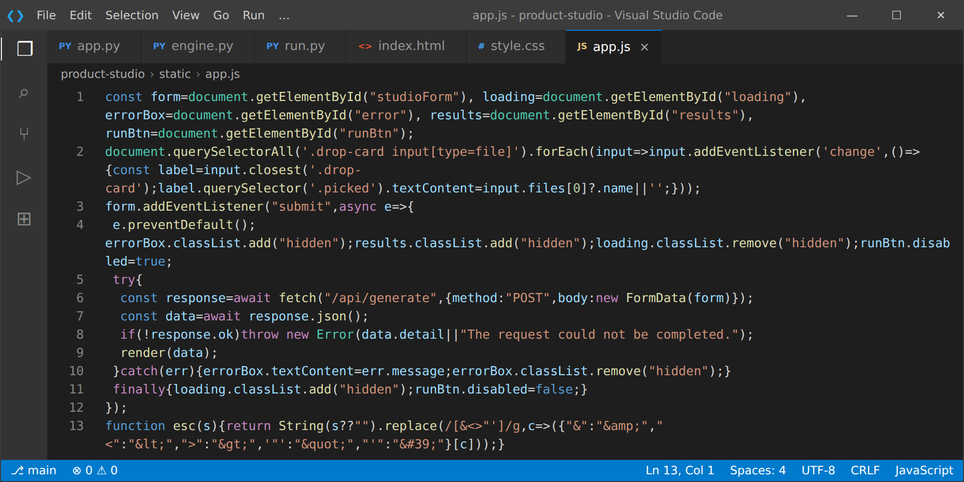
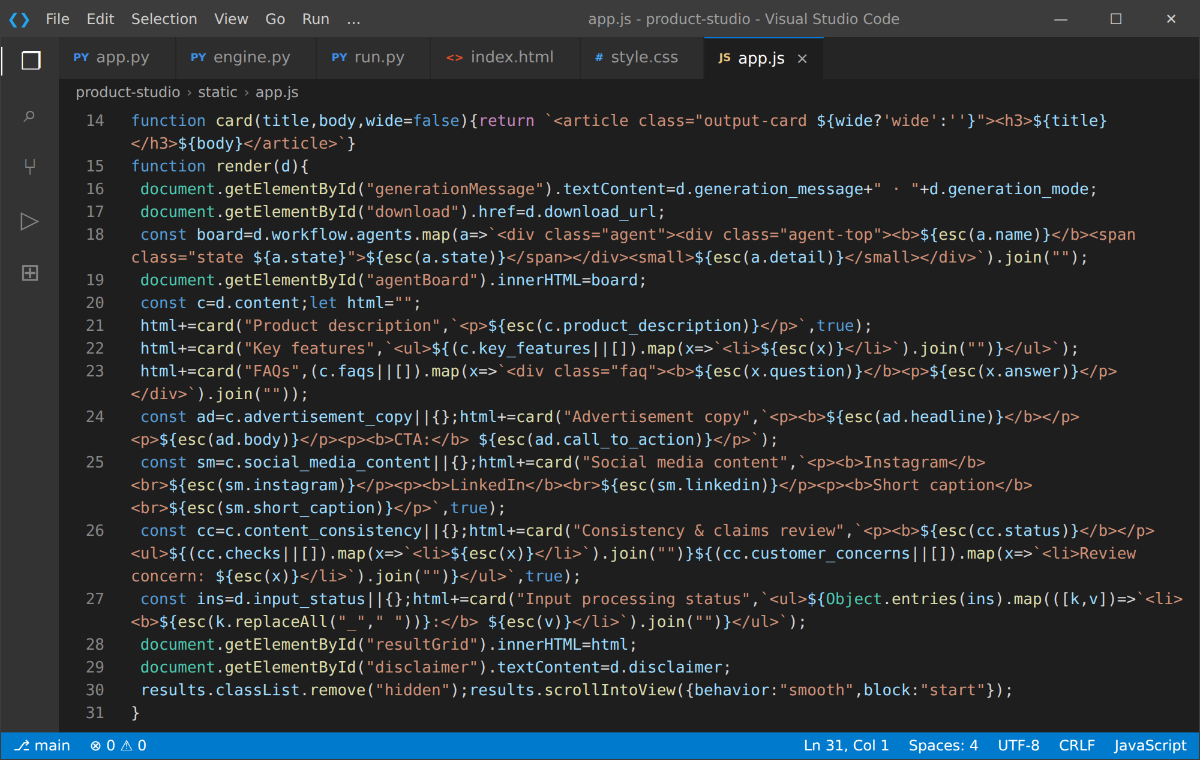

Milestone 5: Deployment and Testing
In Milestone 5, the focus is on deploying the application locally to verify correct operation. This involves configuring the server environment, managing dependencies, launching the app with Uvicorn and testing the complete workflow in both Gemini-enhanced and local fallback modes.

Activity 5.1: Preparing the Application for Local Deployment
Set Up a Virtual Environment:
- Open the project folder in VS Code and open a new PowerShell terminal.
- Create and activate a virtual environment, then install all required dependencies from requirements.txt (see Activity 1.4).
Configure Environment Variables:
- Copy .env.example to .env and add your Gemini API key. Optionally HOST and PORT can also be set in .env; run.py defaults to 127.0.0.1 and port 8000.

Activity 5.2: Launching the Application and Verification
Start the Server:
- Run the application with the launcher, which loads .env before starting Uvicorn:
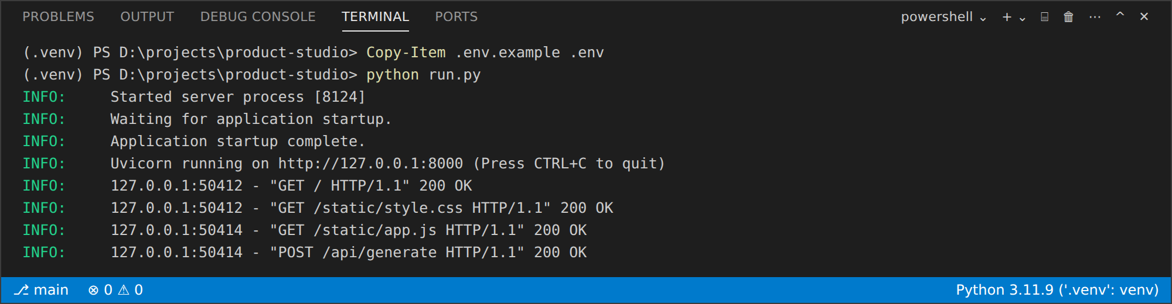
- Open a browser and navigate to http://127.0.0.1:8000 to access the studio. The interactive API documentation is available at http://127.0.0.1:8000/docs.
Verify the Health Endpoint:
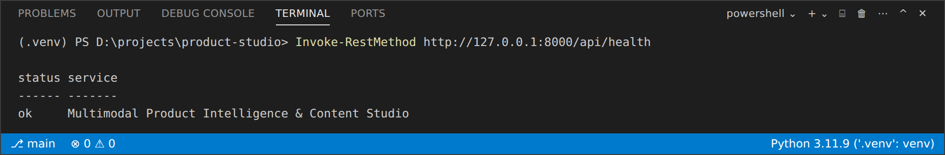

Activity 5.3: End-to-End Testing
Test 1: Gemini-enhanced workflow. Upload a product image, its PDF specification sheet and a reviews file. The agent board shows all six agents complete, and the content cards are generated by Gemini from the extracted facts. The run below used a Marshall Major V headphone sample and produced content_pack_3d10d978c2.json:
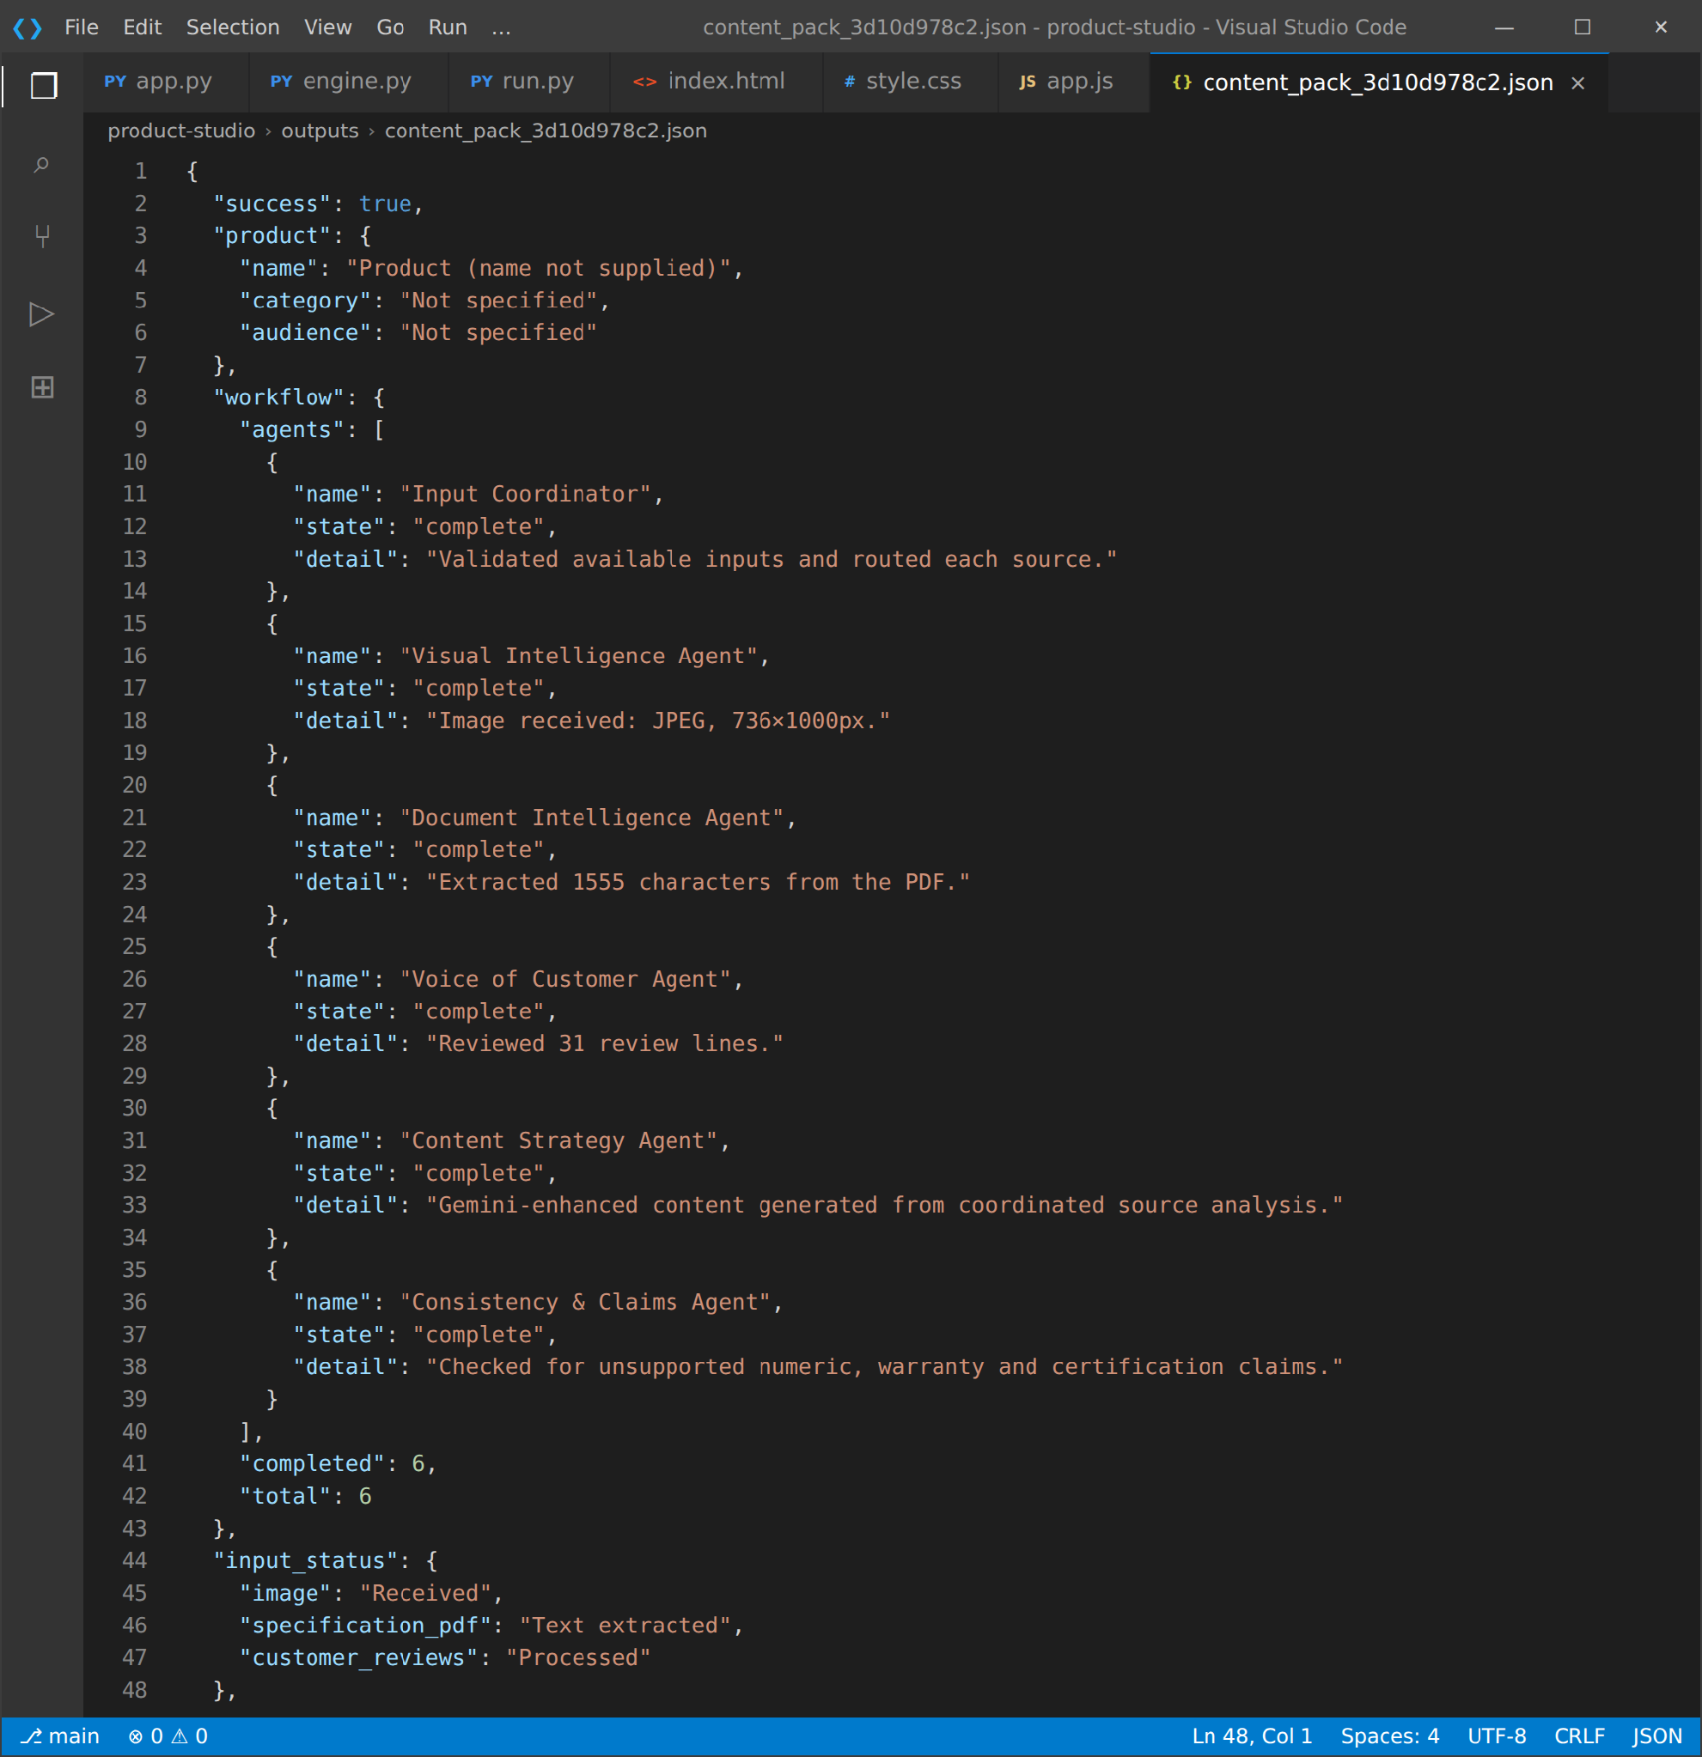
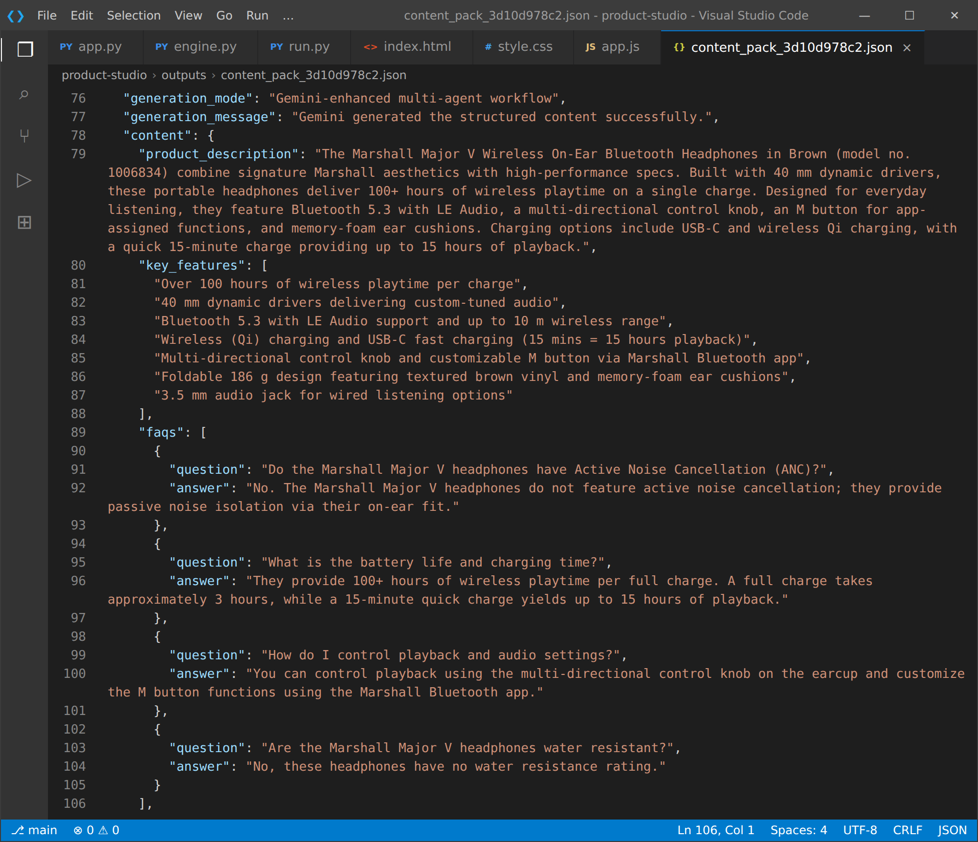
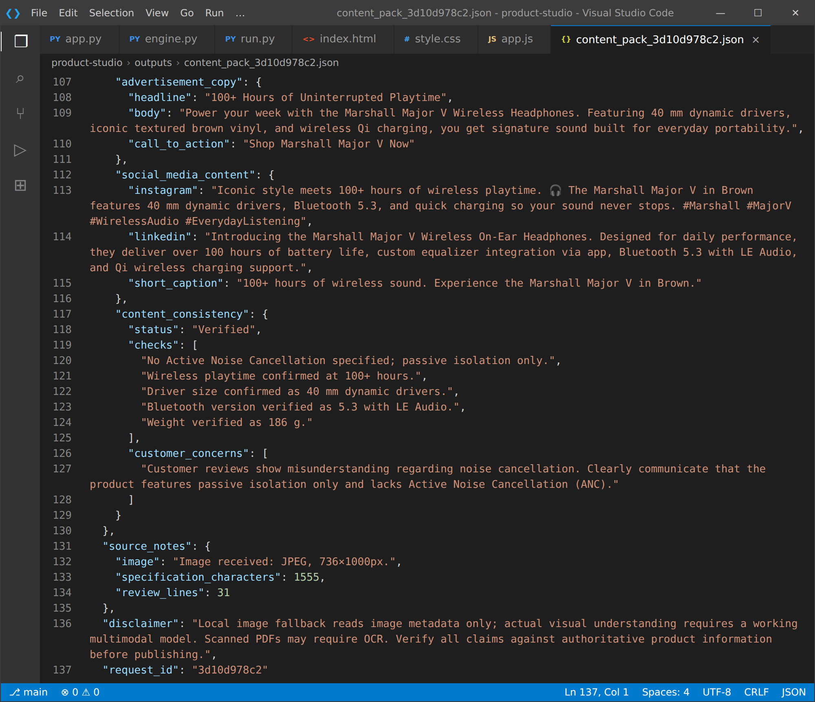
The consistency review confirmed the key facts (100+ hours of playtime, 40 mm drivers, Bluetooth 5.3 with LE Audio, 186 g) and flagged the customer misunderstanding about active noise cancellation.
Test 2: Local fallback workflow. Leave the Gemini key empty, enter a product name, category and audience and upload the sample_reviews.txt file:
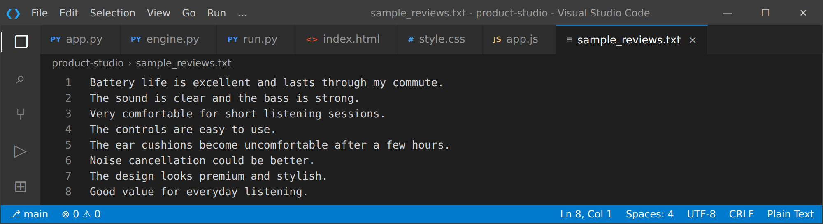

The studio completes without any API call. The Visual and Document agents are marked as skipped, the Voice of Customer Agent reviews eight lines, and the generation message states that Gemini was not used (see the Results Section below for the output).
Test 3: Interface checks. Verify that file names appear in the upload cards, that the loading panel appears while the request runs, that an empty submission shows the error message "Add at least one product detail or input file.", and that the Export JSON button downloads the saved report.
Troubleshooting Notes:
- Port already in use: Change the PORT value in .env or stop the process using port 8000.
- PDF says no text extracted: The PDF may be scanned; the Document Intelligence Agent shows a warning. Use a text-based PDF or run OCR first.
- Gemini quota or API failure: Local generation still completes and the message explains the failure; check your Google AI Studio usage.
- Missing package: Activate .venv and run pip install -r requirements.txt.

Exploring the Website’s Web Pages:

Home / Studio Page:
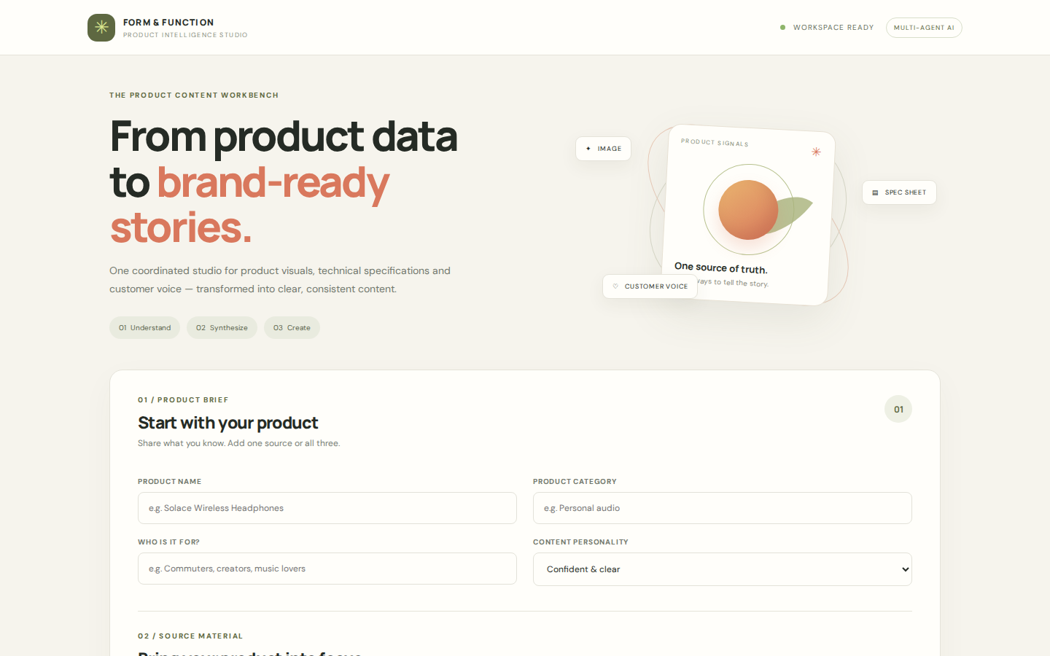
Description: The single-page interface of the Product Intelligence Studio serves as both the landing page and the generation tool. It features a warm, editorial design with a navigation bar showing the Form & Function brand, a "Workspace ready" indicator and a Multi-agent AI badge. The hero section introduces the workbench with the headline "From product data to brand-ready stories" and the three steps Understand, Synthesize and Create. The product brief form and the results panel sit on the same seamless page.

Input Section:
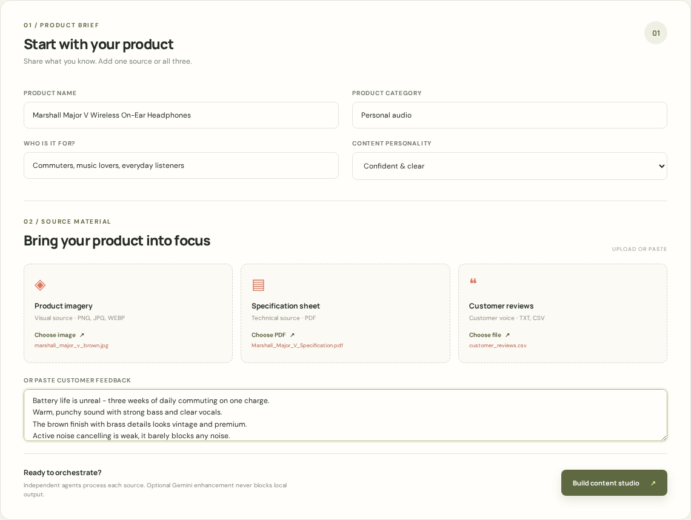
Description: A card containing the product brief and source material. Users enter the product name, category and target audience and choose the content personality (Confident & clear, Warm & friendly, Premium & refined, Bold & energetic or Minimal & factual). Three upload cards accept a product image (PNG, JPG, WEBP), a specification sheet (PDF) and customer reviews (TXT, CSV), and a textarea allows pasting feedback instead. The chosen file names appear inside the cards, and the Build content studio button starts the pipeline.

Results Section:
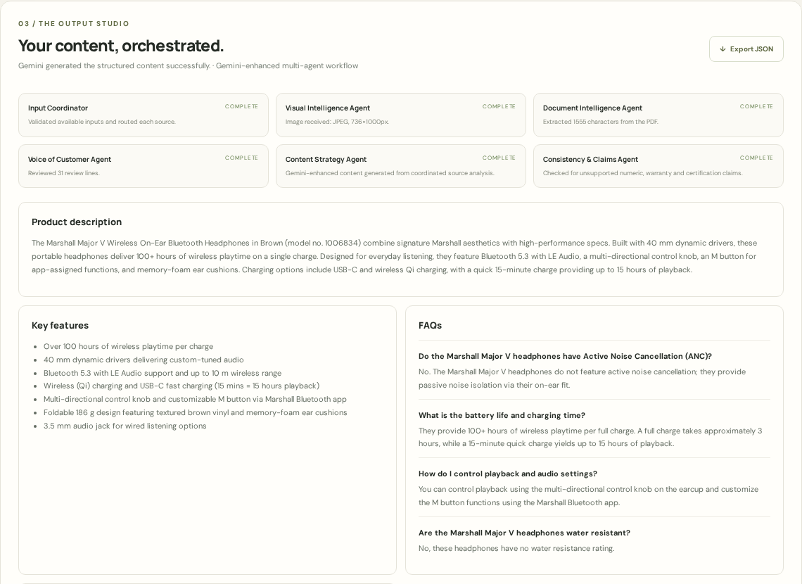
Description: Revealed dynamically after generation, this section shows the generation message, the Export JSON button and the six-agent workflow board with each agent’s status. Below it, the product description spans the full width, while the key features and FAQs sit side by side in a two-column grid.
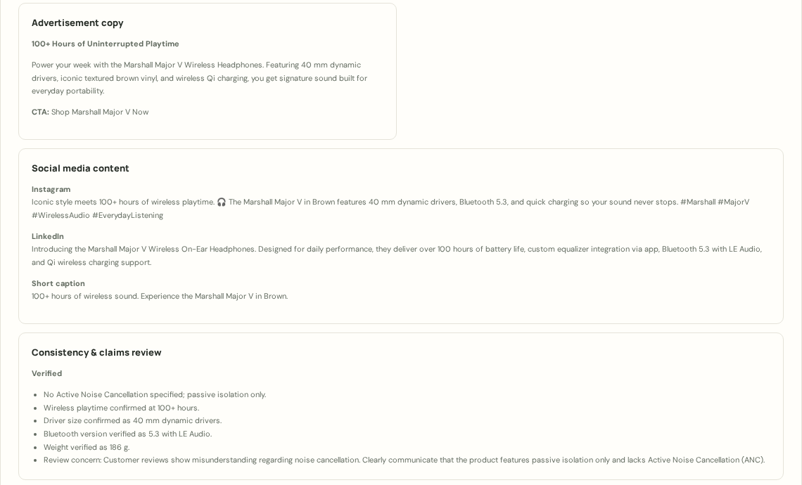
Description: The lower part of the results shows the advertisement copy (headline, body and call to action), the Instagram, LinkedIn and short caption posts, and the Consistency & Claims review with its checks and customer concerns, followed by the input processing status and a disclaimer reminding users to verify claims before publishing.

Local Fallback Output:
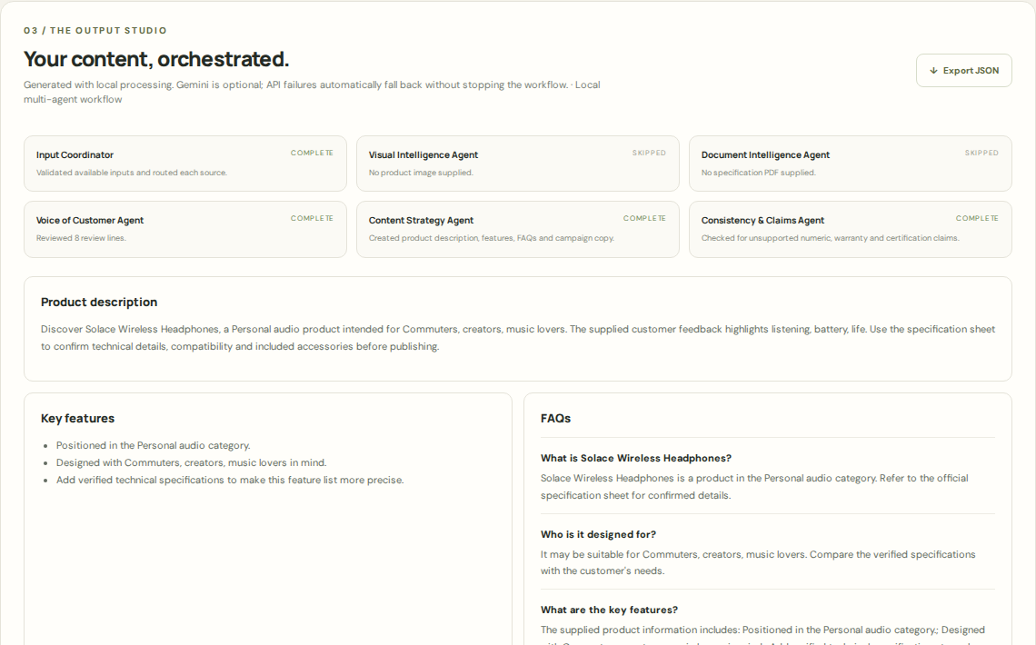
Description: When no Gemini key is configured, the studio still delivers a complete pack. Skipped agents are marked clearly, the status reads "Review required before publishing", and the content stays conservative, limited to the supplied information.

Conclusion:
Multimodal Product Intelligence & Content Studio is a generative AI platform built with FastAPI and a lightweight HTML, CSS and JavaScript interface that streamlines multi-channel product content creation. It combines a local multi-agent engine for PDF extraction, image metadata and review analysis with the Gemini multimodal API to generate product descriptions, key features, FAQs, advertisement copy and social media posts that stay faithful to the source data, supported by a consistency and claims review that catches unsupported statements. The project, which included model selection, backend and frontend development, and local deployment and testing, shows how a local-first design with an optional AI enhancement delivers reliable, structured output even when the external API is unavailable.
Looking ahead, the studio offers significant opportunities for expansion, such as integrating OCR for scanned specification sheets, adding true visual attribute extraction in the local workflow, supporting multiple languages and additional publishing channels, adding user authentication and a database to keep generation history, and automatically cross-checking every generated number against the specification text. By continuously refining the prompts and strengthening the validation layer, the platform is well positioned to evolve from a content generator into a comprehensive product content operations assistant for teams of all sizes.

